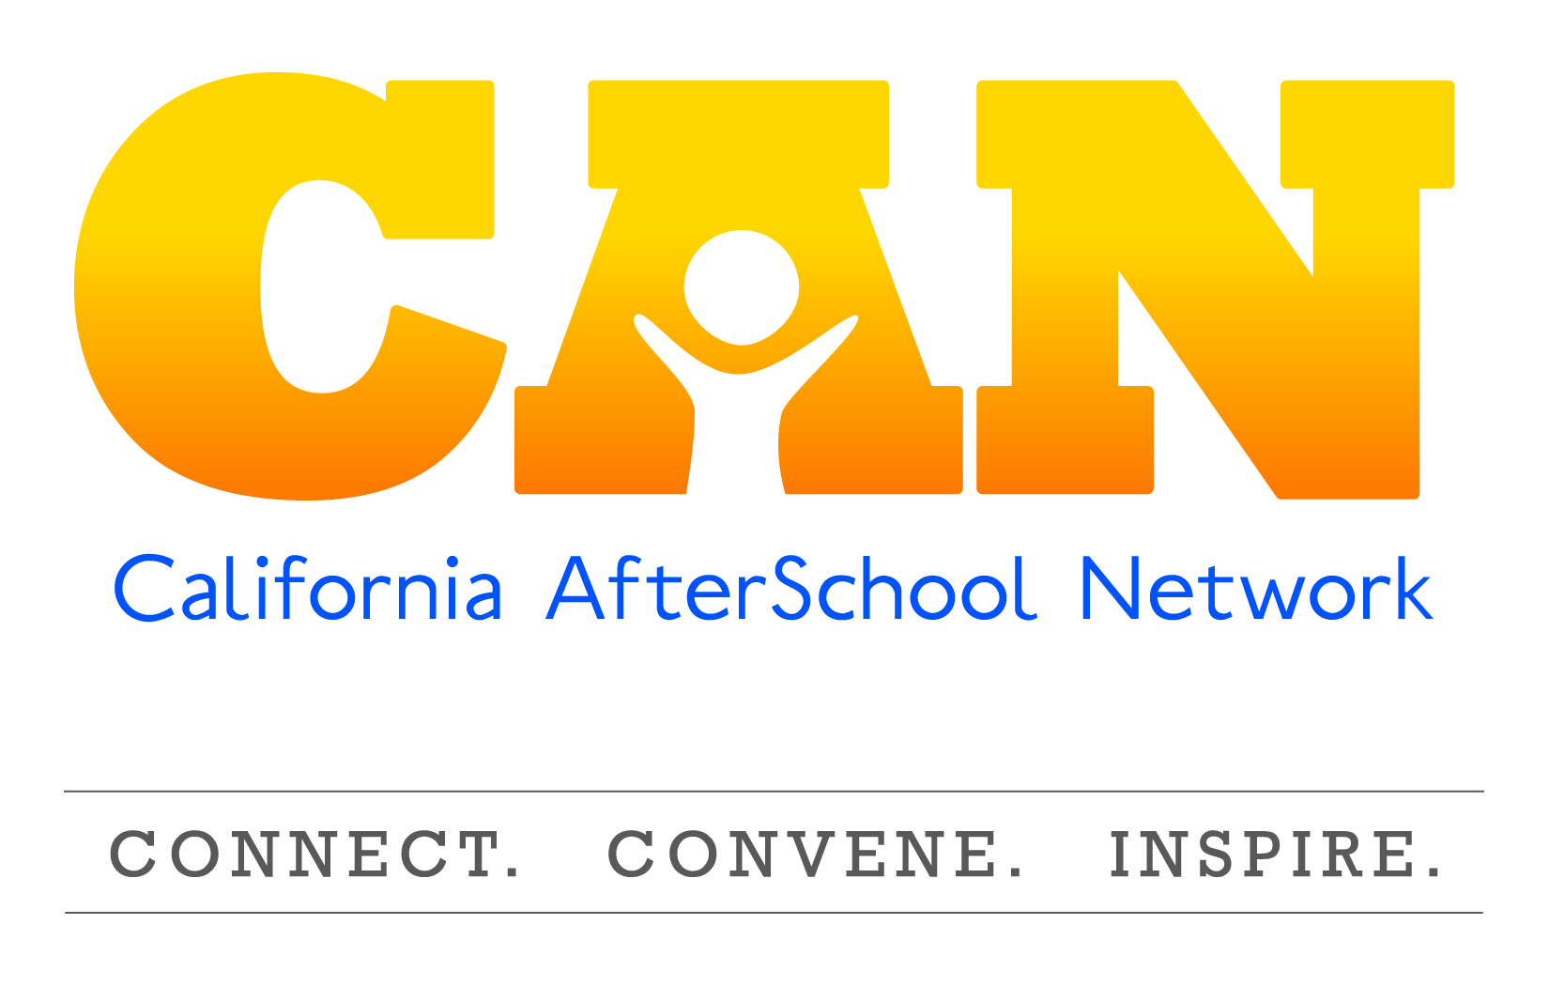

Best Practices of a Continuous Quality Improvement Process
For Expanded Learning Programs

Prior to beginning a CQI Process
- Quality and change are non-negotiable.
  - A commitment to change and quality is needed to CQI to work at all program levels.
- Define Quality
- The Quality Standards for Expanded Learning in California define quality for us.
- Training is essential.
- All staff working in our programs need to be trained on the Quality Standards and the essence of CQI.
- CQI needs to be implemented at the site-level

Assessment Phase
- This does not have to be complicated.
- Ideas to gather data:
- Beginning/Year-end surveys
- Observations
- Collected Student Quotes/Post-its
- Have survey on laptop for parents by sign-in/out sheet
- Larger programs with multiple subcontractors
- May want to consider using an external evaluator
- Keep notes and data results on file
  - Results and summary of results of surveys, observations, interviews, etc.
  - From Stakeholder meetings; especially if discussion of data occurred
  - Available to new staff or site visits

Planning Phase
- Include a variety of stakeholders
- Program leader/staff, parent, teacher, students, school admin
- Start with focusing on one thing
- Can add one or two goals as you master the process
- Keep it simple and make it attainable
- Use language of the Quality Standards
- A Written Improvement Plan is completed for each site!

Improvement Phase
- Inform
What the goals of the program are.
- Inform
- If someone is assigned to an activity, please let them know
- Pay attention what support/TA they need to be successful
- Practice
- Establish Communities of Practice
- Share ideas, challenges, and solutions
- Find programs/sites that have a shared Quality Standard and collaborate on ideas
- Make needed changes
- Don’t wait until the timeline has expired; if you feel a change in the plan is needed—make it!
- Keep notes on Program Improvement Plan (CDE Template great tool)
- Keep notes of meeting/Agendas
- Keep Program Improvement Plan on site
- These are NOT turned into CDE, except upon request.

Creating Goals, Objectives and Activities

- Goal
  - A broad, overarching and intentional target pertaining to the Quality Standard a site commits to enhance
- Objective
- A specific, measureable plan that will take you one step closer to achieving your goal
- Activity
- Daily actions or tasks that are designed/ implemented to assist in the process of completing objectives

