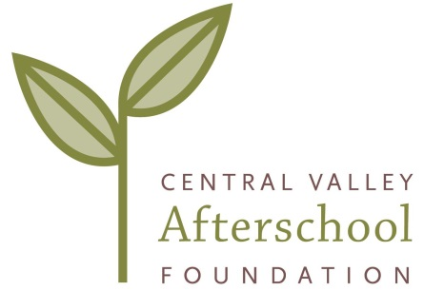

Job Description: Executive Director

The Executive Director (ED) reports to the Board of Directors, and has the overall strategic and operational responsibility for effectively executing the mission of the Central Valley Afterschool Foundation (CVAF).

Responsibilities

Leadership & Management (approximately 40% of position focus):
- Board: Actively engage and energize CVAF Board members. Serve as ex-officio of each committee.
- Partner relationships: Develop and maintain healthy partnerships with other organizations, stakeholders and funders.
- Fund development: Lead and grow revenue generating and fundraising activities to support existing program operations and expansion. Leverage professional contacts and resources to develop new opportunities.
- Grants and contracts: Develop proposals and oversee implementation of grants awarded. Coordinate and manage all CVAF subcontractors.
- Work plan and budget: Work with the Board to develop, implement and manage CVAF work plan and organization budget.
- Public relations: Speak on behalf of CVAF, acting as public relations representative. Oversee marketing and communications efforts. Enhance CVAF image by engaging with a wide range of stakeholders.
- Advocacy: Articulate to policy makers and other stakeholders the crucial role of afterschool programs; ensure research supporting afterschool programs is known and understood.

Programmatic (approximately 60% of position focus):
- Program development: In conjunction with the Board, stakeholders and funders, develop and plan Board-approved projects. Implement programs, ensuring objectives are met.
- Technical assistance: Provide technical assistance and training for CVAF contracts. Ensure ongoing local programmatic excellence, rigorous program evaluation, and consistent quality of finance and administration, fundraising, communications, and systems. Recommend timelines and resources needed to achieve strategic goals.
- Publications: Coordinate the research, development and publishing of CVAF publications, including the Journal of Expanded Learning Opportunities (JELO).

Qualifications
The ED will be thoroughly committed to the mission of Central Valley Afterschool Foundation. Selected candidate will have proven leadership, fund development, and programmatic expertise including but not limited to summer school, supplemental education services, literacy, recreation, and workforce development. Preferred requirements include:
- Master’s degree with management experience.
- Track record of effectively leading an outcomes-based organization and staff.
- Past success working with a board of directors including cultivating board member relationships.
- Strong public relations and fundraising experience with the ability to engage a wide range of stakeholders and cultures.
- Strong written and verbal communication skills; a persuasive communicator with excellent interpersonal skills.
- Ability to work effectively in collaboration with diverse groups of people.
- Passion, integrity, positive attitude, mission-driven and self-directed.

Other
Travel within region required; out-of-region and overnight travel required as needed. A valid California Drivers’ License and proof of insurance are required.

Physical Conditions
- Required job duties include sedentary work with walking, standing, lifting and/or carrying a maximum of 20 pounds.
- Sitting and/or standing with bending and reaching.
- Talking, seeing, reading, speaking and hearing.
- Repetitive use of arms and hands.

Application Information
- Email cover letter and resume to kboyer@centralvalleyafterschool.org
- Opening date: 4/3/17
- Closing date: 5/1/17
- Position starts July 1, 2017
- Questions can be emailed to kboyer@centralvalleyafterschool.org

