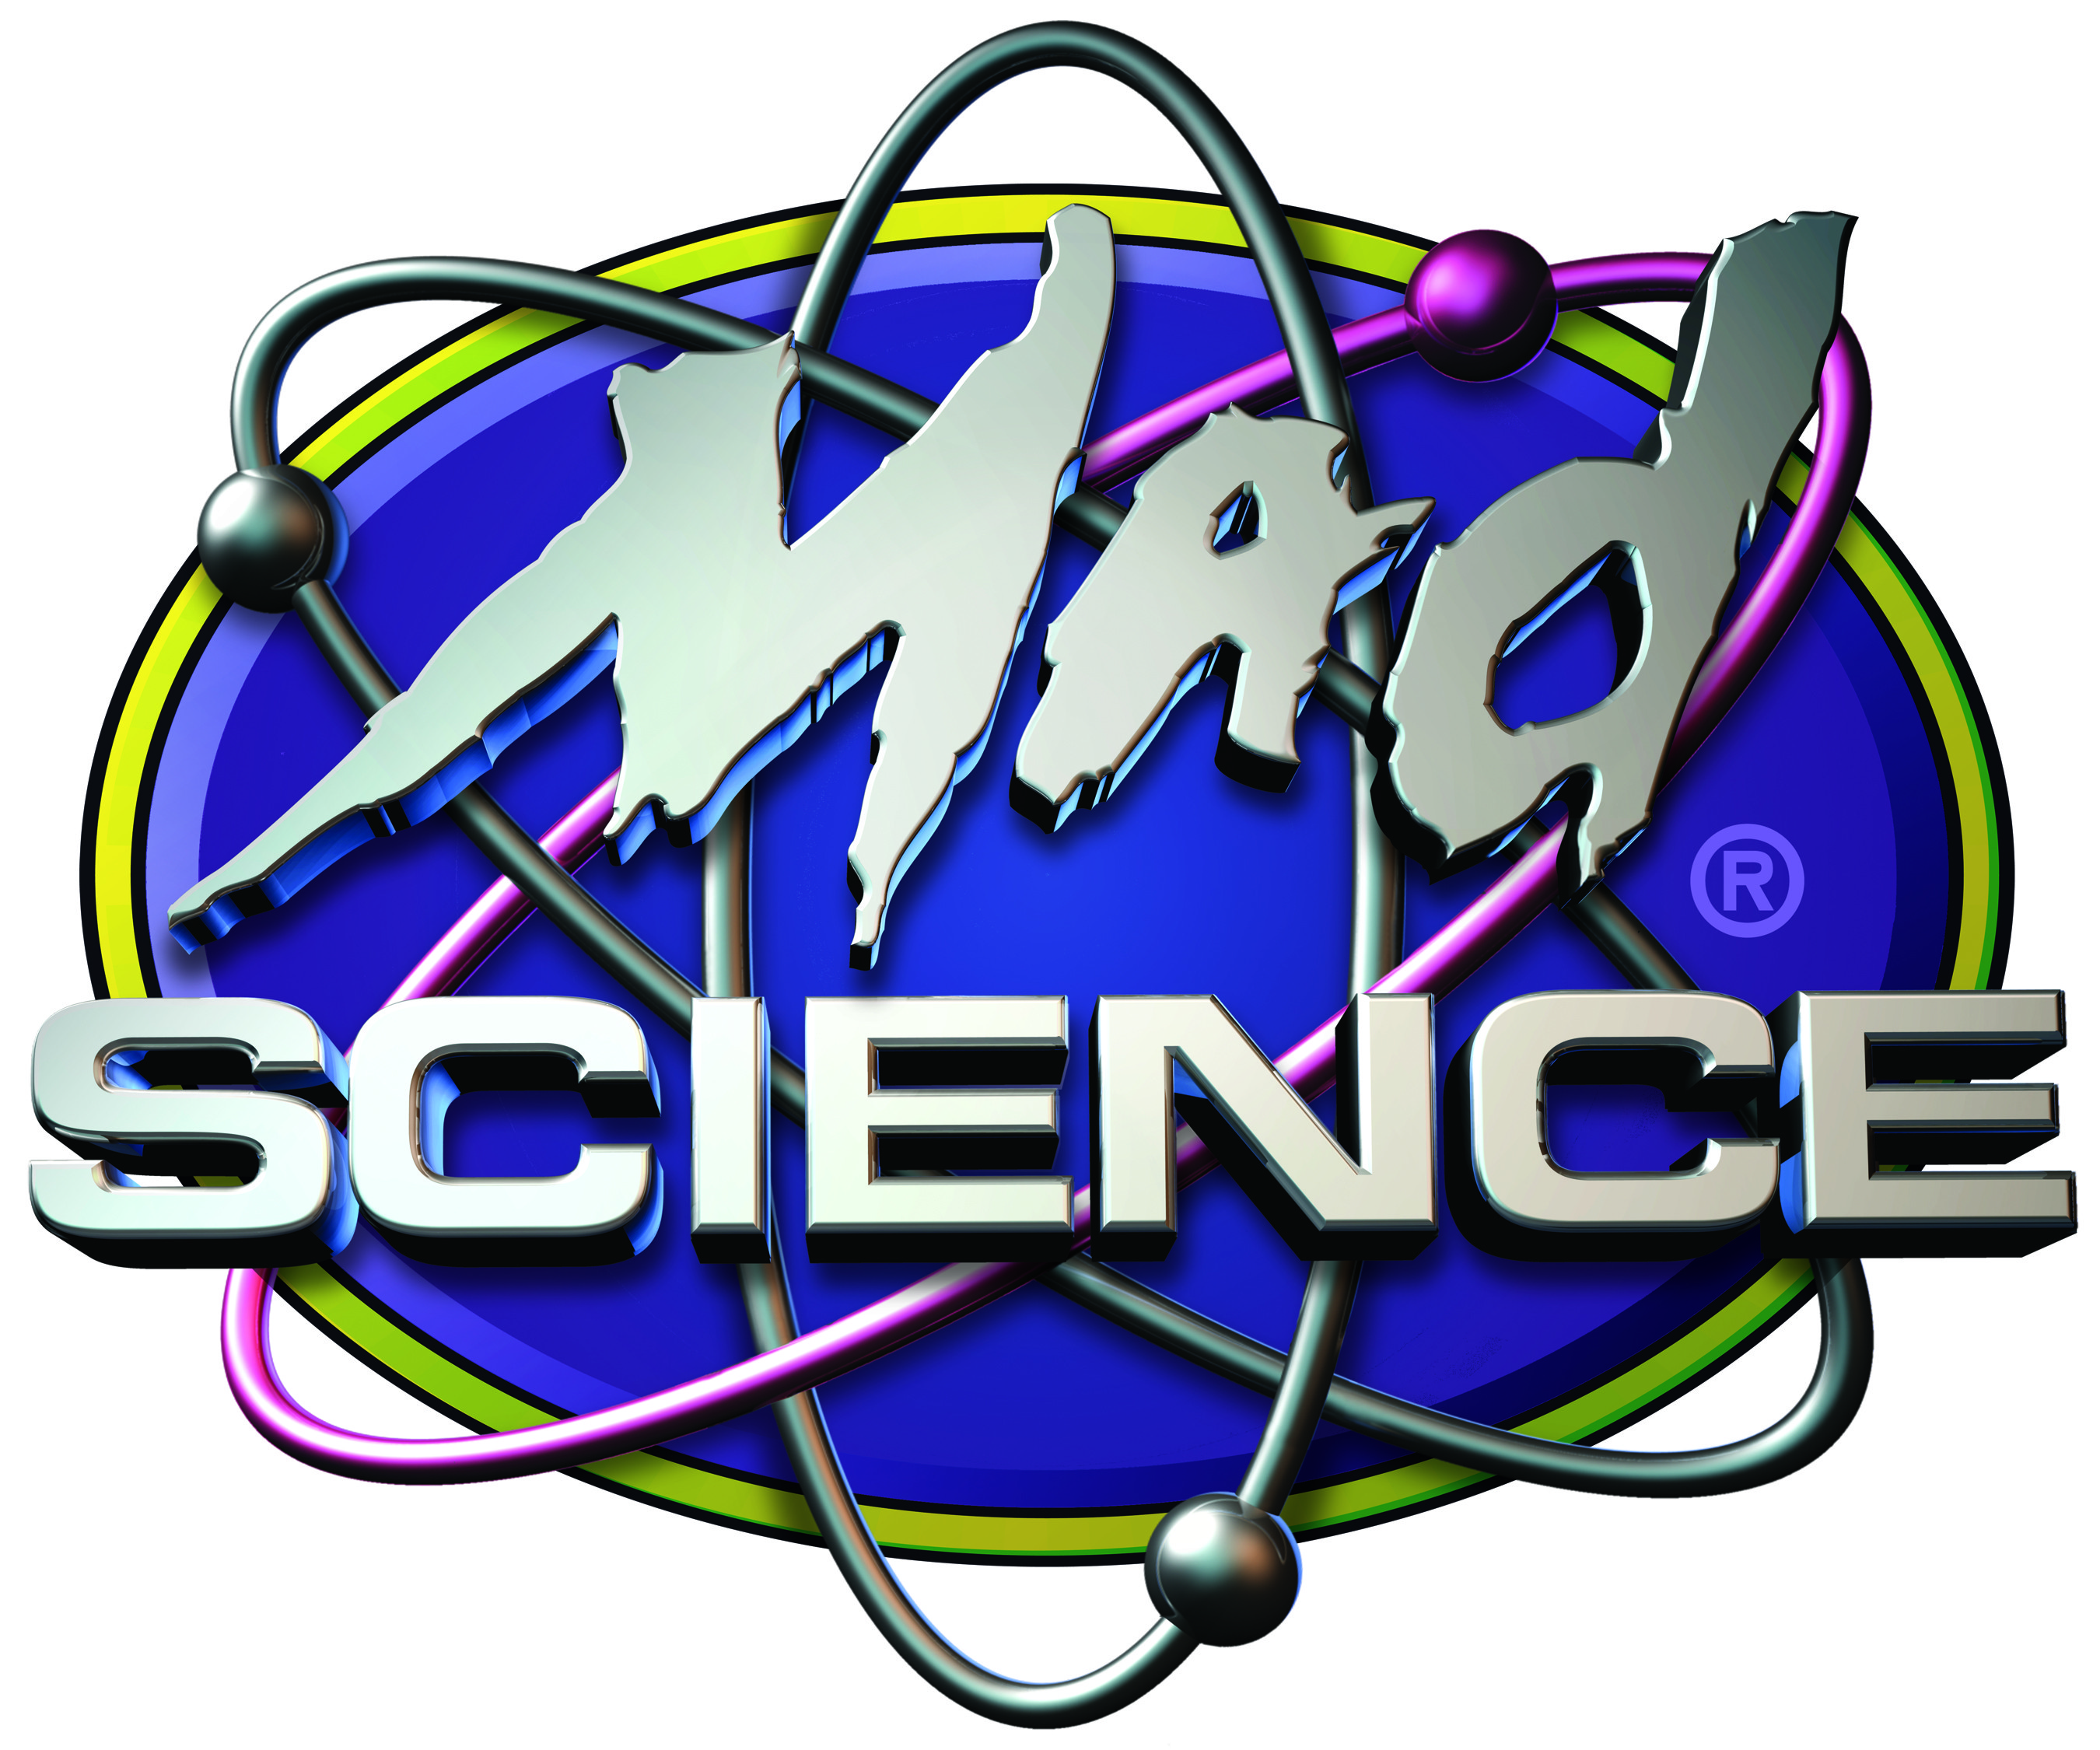
Mad Science of the Bay Area
Positions Available for Fall 2015
Website: http://thebayarea.madscience.org/

This job is a BLAST - literally. Want to have fun and get paid to do it? Mad Science is an “edu-tainment” focused company with the goal of sparking imaginative learning in children between 5 and 12 years of age. Mad Science of the Bay Area is a local franchise of a world-wide company. What is “edu-tainment”? It’s the hybrid between education & entertainment; we want the students to have so much fun that they don’t even realize they’re learning. We want the same thing for our Mad Scientists!
If this sounds like the perfect part-time job for you, APPLY NOW at: http://thebayarea.madscience.org/workforus.aspx
Job Description: We are looking for energetic individuals to be Mad Scientist edu-tainers in our fun after-school science program. This position requires a high-energy, child-friendly individual with access to a reliable car and the ability to work two or more afternoons a week. Experience with kids in a paid or volunteer environment is a must! Have fun and make a difference!
The Mad Scientist position is part-time. Our edu-tainers work approximately 10 hours per week, more or less hours are possible depending on your personal availability. This position is perfect for college students (18 years and older) or others who need an afternoon job with a flexible schedule. Although the majority of our classes occur in the afternoon, frequently classes in the mornings or on weekends are also available.
Mad Scientists are assigned a class load of 2-5 classes per week depending on availability (typically one, but no more than two each afternoon). Each class is an hour long and requires arriving at least 15 minutes early to set-up your equipment and the classroom. Most events are scheduled to begin sometime between 1:00pm and 3:00pm, though classes at other times are frequently available. Our class outline and equipment are all prepared in advance, and we provide training on every class before you are asked to present. Each session is a very high-energy, part entertainment/part education, hands-on class. Each class typically enrolls up to 20 students for a 6 or 8 week session (e.g. class will be every Monday afternoon at 3:00pm). All of our classes are located on-campus at various schools around the Bay Area, you are required to travel to these locations with equipment. You will be scheduled for classes in/around your area.
Qualified Candidates should possess the following experience:
- Previous experience with grade school kids in a formalized (paid or volunteer) setting
- Up-beat, child-friendly personality
- Be able to work a minimum of two afternoons or days per week
- Have a reliable car or access to a reliable car (a MUST)
- Have a valid driver’s license
- Be 18+ years of age
- Able to pass a California and Federal background check
- Looking for PART-TIME work
- Be able to attend one mandatory staff meeting per quarter (scheduled in advance)
- Able to attend mandatory training and orientation.
Additional Information: The Mad Scientist position is a part-time job (during the school year). Compensation begins at $20-$25 per one-hour class. Mileage reimbursement is available in certain instances.
We are now accepting applications! Don’t delay!
If this sounds like the perfect part-time job for you, APPLY NOW at: http://thebayarea.madscience.org/workforus.aspx
For more information about what our programs are like, check us out on YouTube at the following link: https://www.youtube.com/watch?v=5O_bOAOVebk

