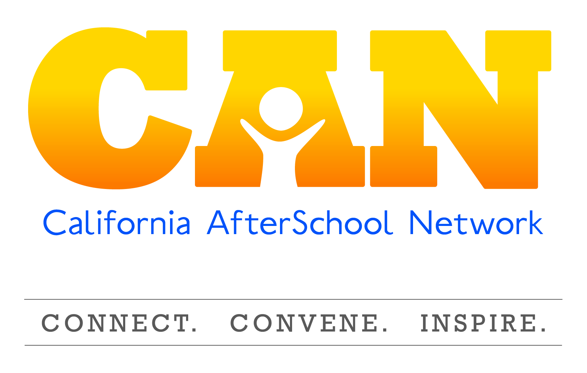
Policy Committee Meeting Summary
November 25, 2014

Speakers:
- Jessica Gunderson, Senior Policy Director for the Partnership For Children and Youth
- Brian Lee: State Director, Fight Crime Invest in Kids California
- Erik Peterson: Vice President, Policy, Afterschool Alliance
- Mary Jo Ginty: Region 11 Lead, Los Angeles County Office of Education

Access the audio recording of this meeting.

California Election updates:

Governor, Superintendent, and State Legislature
- Jerry Brown was elected easily for his second term
- There was a heavily contested race for Superintendent of Public Instruction. Tom Torlakson, a long-term supporter of expanded learning in the legislature and as Superintendent, won his election and will serve a second term.
- New voting rules in CA require that the top two candidates in the primary, regardless of political party, advance to the election. This resulted in a variety Democrat vs. Democrat races and Republican vs. Republican races.
- Republicans gained seats in the California legislature. Democrats now no longer have a super-majority (2/3 of the seats) in the legislature. Super-majority votes (2/3 votes) are required for overturning vetoes (which is very rare) and raising taxes (which the voters already put in place by approving proposition 30). Democrats still maintain a large majority in both the CA Assembly and CA Senate.
- Most notable shifts as a result of the election include:
  - Assembly member Muratsuchi (D-Torrance), chair of Assembly Budget Sub-Committee on Education was unseated by Republican David Hadley (by 706 votes).
  - Raul Bocanegra was unseated by a Democrat, Patty Lopez (by 467 votes).
  - Kevin De Leon takes place of Darrel Steinberg (who had reached his term limit) as Senate Speaker Pro Tem
  - Tony Atkins replaces John Perez (who had reached his term limit) as Speaker of the Assembly
- On the horizon:
  - There will soon be a new chair of Assembly Education Committee, Senate Appropriations Committee, as well as the Budget Sub-Committee on Education.
  - It may be strategic to provide information on the importance of expanded learning, and issues related to expanded learning to these new Committee chairs.

Federal House and Senate
- CA Democrats gained a seat for their congressional delegation.
- Barbara Boxer and Dianne Feinstein may be seeking retirement in the near future.

State Ballot Initiatives:
- Proposition 47: a criminal justice reform initiative transferred some offenses from Felonies to Misdemeanors, which is projected to result in a savings of hundreds of millions of dollars. 25% of the savings is expected to go to education, while other funds will go to substance abuse prevention, and mental health.
- It is possible that the CDE would have control of these funds for specific purposes, or it may be implemented similar to local control funding.

State budget
- A budget passed in July 2014.
- The Legislative Analyst Office expects that there will be billions more dollars projected for education this year (2014/15), and in 2015/16. These projections are based on expected revenue. While education will be bolstered, there will not be a lot of funds available for the overall general fund for other opportunities.
- The Governor will release his first draft of next year’s budget in January.
- Child Care funding has historically been cut; however last year’s budget did contain minor increases in child care funding for more available slots. Much of recent child care discussions have been focused on early learning. Therefore, there may be more of a move in the near future to focus on increasing child care rates, and other development in child care due to the pent up demand created by historic cuts. This is a huge priority for the Legislative Women’s Caucus.

Legislative updates
SB 1221 and SB 949 were signed into law.
- SB 1221
  - Sponsored by the CDE and the Partnership for Children and Youth.
  - Prioritizes 21st CCLC applications from programs that support year-round learning opportunities.
  - Updates program reporting requirements for future 21st CCLC and ASES programs by removing the now defunct standardized tests. It does not require existing 21st CCLC programs to shift their current priorities.
    - Existing ASES programs can also apply for 21st CCLC supplemental funding to provide summer programs only without applying for the core funding, which is now more explicit than it has been in the past.
  - Attendance is still prioritized and now must be linked to the student identifier.
  - Instead of reporting on test scores, programs will now need to offer evidence they participate in a process of continuous quality improvement related to the recently adopted Quality Standards for Expanded Learning in CA.
  - Requires the department of education to develop a bi-annual report to the legislature on outcomes and information on students served. This data will be individual student, instead of school site.
  - Set a minimum grant for ASES programs at $27,000, which impacts rural programs.
  - Allows for the potential for transportation grants for “frontier sites” a designation for extreme rural sites.
  - The law will go into effect in January 2015, with the implementation will be led by the CDE After School Division, and is being informed by CDE Strategic Implementation Teams (specifically the Policy Guide Committee). These teams are comprised of members of the CDE After School Division and stakeholders from the field.

- SB 949
- Sponsored by the YMCA of CA, this bill will established the DASH
(Distinguished After School Health) standards.
- To be implemented by the CDE After School Division.
- The program is voluntary and expanded learning programs self-certify for
the distinction. Programs can apply via the CDE website and self-certify that they meet the requirements.
- In order to be fully implemented, the program must be funded through
appropriations.

Potential legislative priorities for 2015
The legislature is currently being signed in and many are beginning to shape their legislative priorities, including the California Afterschool Advocacy Alliance (CA3)

Increasing ASES Funding
- CA3 is exploring ways to propose an increase in ASES overall funding, and daily rates (per student) to address cost pressures created by the increase in minimum wage, as well as changes to the cost of doing business since the funding levels were set in 2006. Last year this priority was addressed with legislators through the CA After School Challenge, however policy leaders were not successful in increasing the overall funding levels, or the daily rate for ASES.
  - The focus is on increasing overall funding levels for ASES, because increasing the daily rate (per student) without an overall funding increase reduces the numbers of programs that could be funded.
  - The focus is on ASES programs, because 21st CCLC is a federal program, so the congress controls funding levels)
  - There is not a clear understanding now where this funding would come from; it is possible that the proposal would be for it to come from the general fund, or from Prop. 98 (education) funding.

Local Control Funding Formula (LCFF)
- Under Local Control Funding Formula (LCFF), Local Control Accountability Plans (LCAPs) must be submitted by Districts to County Offices of Education.
- LCAPs were submitted, and were reviewed by their COEs by October 8, 2014.
- A recent EdSource article outlined that County Offices of Education approved 98% of the LCAPs submitted.
- In November, the State Board adopted the final LCFF regulations. The State Board is now developing evaluation rubrics for LCAPs in collaboration WestED. The State Board will release the rubrics in Spring 2015, at which point there will be opportunity for comment.
- This will not allow for districts to update their plans in 2015 in response to the rubric because the rubric will likely not be approved until Oct. 1 and new LCAPs will be submitted in July 2015, and approved in September 2015.
- County offices are experiencing challenges with the rollout of LCFF, as they do not have funded staff to review LCAPs. Many COE’s have not seen decreased revenues with LCFF, paired with increased responsibility to review LCAPs.
- Agenda item for next policy call- further implications of LCFF and LCAPs on Districts and Expanded Learning Programs
- View the WestED LCFF website to learn more.
- The Partnership for Children and Youth did review 60 LCAPs to assess investment in expanded learning. Contact Jessica Gunderson at jessica@partnerforchildren.org for more information.

Federal Policy updates

Federal Elections:
Republicans will be in control of the Senate and the House in Jan. 2015. This is the largest majority by one party in the House of Representatives since 1928.
- Implications on committees
  - Senate Health Education and Labor Committee
    - New chairman will be Senator Alexander from Tennessee.
    - Ranking member will be Senator Murray from Washington
  - House Education and Workforce Committee
    - Chairman will continue to be Congressman Klien from Minnesota
    - Ranking member (replacing George Miller who retired) will be Congressman Bobby Scott from Virginia
- Appropriations committees:
- House of Representatives: the new chairman will be Congressman Cole from
Oklahoma, and the ranking member will be Congresswoman DeLauro from
Connecticut.
- It is still unclear what the leadership will be for the Senate Appropriations
Committee.

- Lame duck session
- This session will conclude by mid-December.
- Congress reauthorized the Child Care Development Block Grant for the first time in 18 years. Proposed changes pertain specifically to safety and improving quality. There will now be minimum number of safety inspections even when programs are license-exempt.
- The next step is to provide guidance on what the changes mean, and how they will be implemented.

Appropriations and spending bill
- We are currently in a continuing budget resolution that will conclude on December 11, 2014. There are three possibilities, with negotiations currently taking place:
  - Passage of an Omnibus spending bill (which could include increases or cuts to budget items).
  - Another continuing resolution (which would keep funding exactly as is).
  - A federal government shut down.
- For the Omnibus, there are some questions about “deal-breaker” policy riders that would prevent this spending bill from coming to fruition.

Child Protections Improvement Act
- Would extend a successful pilot program and would require at-cost background checks for youth-serving programs.
- This would impact on 32 states where providers do not have access to cost-effective federal background checks, or only have access to state background checks that would not surface if individuals had infractions outside of the state.

Federal Policy next year
- Spending Bill if not passed in the Lame Duck Session.
- Elementary Secondary Education Act.
- America Competes – supporting STEM learning in expanded learning programs.
- Child nutrition – ensuring programs can operate the meal programs seamlessly, year round.

California Expanded Learning Administrative updates
- ASES renewal and ASES Universal Grants
  - ASD had hoped to release applications in September/October with a January due-date.
  - It is expected that this will be released very soon with a due date of Feb. 15th for both ASES Universal and Renewal.
- 21st CCLC will not be available for another 2 years, when it is expected there will be a new RFP for 21st Century funding.
- Regional Leads historically have been funded historically through a grant to provide Technical Assistance to expanded learning programs. There is a move to fund regional technical assistance through a contract because ASD has had some legal guidance that they must release contracts instead of grants, which also will give CDE a bit more control around accountability of their contractors. The RFP was released in September and due to a number of issues the RFA was ultimately retracted.
- Regional Leads will be funded through 15/16 with a grant while the After School Division revises the RFA to release it in 2016/2017.
- CDE ASD is implementing the strategic plan that it has adopted, and there are seven committees working on the implementation. These groups are comprised of field representatives and CDE staff. Most groups have only met once.
- CA ranked number one for After School nationally in the America After 3pm, national household survey of expanded learning nationally conducted by the
- Quality Standards for Expanded Learning and the Standards in Action have been approved and released in mid-September, and the rollout is being planned.
- The big push is to understand that the standards are not for evaluation and assessment, but should be used as the foundation of a continuous quality improvement cycle. Rollout is now beginning and highlighted during the winter conferences in many regions.

Next meeting:
March 5, 2015 at 11am – 12:00pm

Encouragement – invite legislators to visit the program, and access information and supporting materials to share with them during their visits.

