Site Coordinator Community of Practice
Year 2 Teambuilding

Marshmallow Challenge

Step 1: Schedule a Meeting
Find 45-60 minutes when your team can fully engage in the challenge. I’ve run challenges with groups containing as four people to as many as 800 people. Ensure that you have tables for each team.

Step 2: Assemble a Kit for each Team
In advance of the meeting, create a marshmallow challenge kit for each team, with each kit containing twenty sticks of spaghetti, one yard of masking tape, one yard of string and one marshmallow. These ingredients should be placed into a paper lunch bag, which simplifies distribution and hides the contents, maximizing the element of surprise.
- Spaghetti: Ensure that you use uncooked spaghetti. Avoid spaghetti as it is too thin and breaks easily. Fettuccini is too thick.
- String: Include string that can be easily broken by hand. If the string is thick, include scissors in your kit.
- Marshmallow: Use a name brand or private label brand of marshmallows that measure the ‘standard’ size, about an inch an a half across. Avoid mini or jumbo marshmallows. Also avoid stale marshmallows. You’ll want squishy marshmallows that give the impression of lightness.
- Masking Tape: Get standard masking tape. Generally, you’ll want to put the tape on the side of the table, the back of a chair or a nearby wall. Rolling it in the bag tangles the tape.
- Paper Lunch Bags: Standard size lunch bags work well as do letter size manila envelopes.
Also ensure that you have the following tools to run the challenge:
- Measuring Tape: Have a contractor’s retractable measuring tape available after the challenge is finished so you can measure the height of the structures.
- Countdown App or Stopwatch: The actual marshmallow challenge takes eighteen minutes. Eighteen minutes seems to be the magic time. Twenty minutes is too long and fifteen is too short. You can use a stopwatch, but better yet is to use a video projector and display the countdown time.
- Video Projector and Sound System (optional): For more impact, use a video projector to deliver the Marshmallow Challenge Presentation (or your own) and a sound system for music during the challenge. Time out a play list of exactly 18 minutes of music. You’ll want the challenge to end at the conclusion of the last song.

Step 3: Deliver Clear Instructions
Be clear about the goals and rules of the Marshmallow Challenge. Use the Acrobat Presentation to introduce the challenge as well as to visually reinforce the instructions:
- Build the Tallest Freestanding Structure: The winning team is the one that has the tallest structure measured from the table top surface to the top of the marshmallow. That means the structure cannot be suspended from a higher structure, like a chair, ceiling or chandelier.
- The Entire Marshmallow must be on top: The entire marshmallow needs to be on the top of the structure. Cutting or eating part of the marshmallow disqualifies the team.
- Use as Much or as Little of the Kit: The team can use as many or as few of the 20 spaghetti sticks, as much or as little of the string or tape. The team cannot use the paper bag as part of their structure.
- Break up the Spaghetti, String or Tape: Teams are free to break the spaghetti, cut up the tape and string to create new structures.
- The Challenge Lasts 18 minutes: Teams cannot hold on to the structure when the time runs out. Those touching or supporting the structure at the end of the exercise will be disqualified.
- Ensure Everyone Understands the Rules: Don’t worry about repeating the rules too many times. Repeat them at least three times. Ask if anyone has any questions before starting.

Step 4: Start the Challenge
Start the countdown clock and the music with the start of the challenge.
- Walk around the Room: It’s amazing to see the development of the structures as well as notice the patterns of innovation most teams follow.
- Remind the Teams of the Time: Countdown the time. Usually, I call 12 minutes, 9 minutes (half-way through), 7 minutes, 5 minutes, 3 minutes, 2 minutes, 1 minute, 30 seconds and a ten-second count down.
- Call Out How the Teams are Doing: Let the entire group know how teams are progressing. Call out each time a team builds a standing structure. Build a friendly rivalry. Encourage people to look around. Don’t be afraid to raise the energy and the stakes.
- Remind the Teams that Holders will be Disqualified: Several teams will have the powerful desire to hold on to their structure at the end. Usually because the marshmallow, which they just placed onto their structure moments before, causing the structure to buckle. The winning structure needs to be stable.

Step 5: Finish the Challenge
After the clock runs out, ask everyone in the room to sit down so everyone can see the structures. Likely, just over half the teams will have standing structures.
- Measure the Structures: From the shortest standing structure to the tallest, measure and call out the heights. If you’re documenting the challenge, have someone record the heights.
- Identify the Winning Team: Ensure they get a standing ovation and a prize (if you’ve offered one).
- Wrap up with the Lessons of the Marshmallow Challenge: Deliver the attached presentation or just describe some of the key lessons of the marshmallow challenge:
- Kids do Better than Business Students: On virtually every measure of innovation, kindergarteners create taller and more interesting structures.
- Prototyping Matters: The reason kids do better than business school students is kids spend more time playing and prototyping. They naturally start with the marshmallow and stick in the sticks. The Business School students spend a vast amount of time planning, then executing on the plan, with almost no time to fix the design once they put the marshmallow on top.
- The Marshmallow is a Metaphor for the Hidden Assumptions of a Project: The assumption in the Marshmallow Challenge is that marshmallows are light and fluffy and easily supported by the spaghetti sticks. When you actually try to build the structure, the marshmallows don’t seem so light. The lesson in the marshmallow challenge is that we need to identify the assumptions in our project – the real customer needs, the cost of the product, the duration of the service – and test them early and often. That’s the mechanism that leads to effective innovation.

Zoom!

Here are three variations of the group activity “warp speed” where participants attempt to “move” something around the circle, as quickly as possible. Begin with a full-sized raccoon circle, with all participants holding onto the webbing. In this first version, the knot in the webbing becomes the object that is passed around the circle, and timed with a stopwatch. The challenge or goal is to see if the group can creatively problem solve a technique for reducing the amount of time required for the knot to traverse one revolution of the circle. Version two includes one person the group clapping and passing this clap around the circle, with each participant clapping once. Version three eliminates the tactile passing of the knot or clap and replaces them with each person saying zoom, for a verbal version of this activity.

Yurt Circle

Equipment: A strong rope or one-inch tubular webbing is required. The length of the rope or webbing should be about one foot per person in the group. Tie the rope into a big loop using a square knot or water knot.

Equipment Required: A long length of rope, 50 to 75 feet depending on the size of the group. Just over 50 feet should be long enough for the average team of 20 players. The rope should be at least 5/8 inch thick and very strong. Tie the two ends together with a suitable knot. Do not use a knot that you are unsure will hold considerable weight. A Figure 8 Bend would work well, but a double fisherman should be adequate.

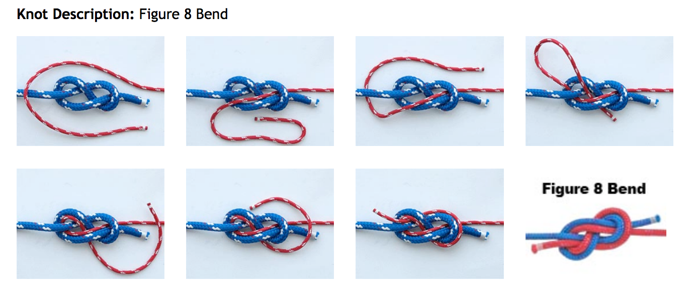

Procedure: Have the group stand in a circle. Have the group grasp the rope or webbing with both hands knuckles up and plant their feet. Explain that you will count to three and then say “lean.” When you say “lean” all group members are to gently and slowly lean back without moving their feet or letting go of the rope/webbing. Emphasize that you expect the rope/webbing to be held perfectly still. While the group is leaning back supporting each other count to three and say “stand.” Practice this several times. When you feel the group is ready tell them the next step is to sit. Tell them you will instruct them to lean as before. When the rope/webbing is still you will count to three and say “sit.” All group members are to slowly and carefully sit down without moving their feet or letting go of the rope/webbing. Once they are down, count to three and say “stand.” All group members are to slowly and carefully stand up without moving feet or letting go of the rope/webbing. Most groups will want to do this several times.

Directions:
- Have everyone stand in a circle and take a hold of the rope or webbing.
- Using communication within the group, the group needs to fully lean back, having each member on their heels (with their toes in the air). The facilitator should stress the importance of everyone participating and not yanking on the rope. If participants start yanking on the rope or not putting effort, they should be immediately taken out of the group. (
- Once the group has success, you can try these alternatives:
  - Have the group sit as a group using the yurt circle.
  - Have the group stand back up using the yurt circle.
  - Count off the students by 2s. Have 1s lean back and 2s lean forward. Only do this if they are showing success and good communication
***Facilitator Note: Lay the rope out in a large circle and instruct the participants to stand outside the rope circle equally spaced. The participants should hold the rope with their hands shoulder width apart. They should then spread their legs to shoulder width as well, and then lean back creating tension on the rope. They should slowly bend their knees until everyone makes contact with their rear ends on the ground at about the same time. Next ask them to stand together. If they coordinate well, they should be able to maintain equilibrium and stand at the same time.

Debriefing Tips: This exercise demonstrates how cooperation makes things happen in a much more efficient manner.
- What would have happened if one person decided to let go?
- Do you believe that everyone in this group can be trusted to do their part?
- Did everyone in the group show they could be trusted?
- What can group members do to make you feel they can be trusted?
- In what other situation at school is it important that all group members be trustworthy or be counted upon to do their part?
- If someone slips, the whole circle will collapse. If someone bends, the whole circle will collapse. If someone lets go… Well, you get the idea. Everything must work perfectly for this to work! The group must fully trust each other.
- If you want to discuss symbols you can discuss the circle itself. Circles mean that there is only one team, and that everyone is equal!
- Life is a constant balancing act when working with other people. Sometimes you need to pull more and sometimes you need to let up, just like when you’re in the circle.
- Is it easier to trust some people and not others? Explain? Does the situation matter?
- How do you increase your trust for someone?
- Can you think of examples of when trusting someone might not be a good idea?

Interference

Here is a communication challenge from Tom Heck that is loud and playful, but still carries a significant message about how we communicate. Using two raccoon circles as boundary lines create the activity space show below. In this space the “senders” occupy the left “endzone,” the “interferers” occupy the middle space, and the “receivers” occupy the right “endzone.” The challenge is not for the senders to verbally or visually communicate the message to the receivers while the interferers in the center region attempt to disrupt the message, distract the senders of receivers, and basically add a great deal of chaos, noise and confusion to the activity.

After 30 seconds, the receivers are asked for the message. Then the three distinct groups switch to new roles (interferers becomes receivers, receivers becomes senders, senders becomes interferers) and a new message is delivered.

