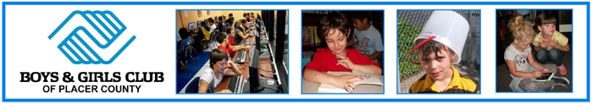
679 Lincoln Way, Auburn, CA 95603
Phone 530-889-2273 / FAX 530-889-2532
Email: kmccaughna@bgcplacercounty.org
NOW HIRING

Youth Development Specialist
Boys & Girls Club of Placer County—various locations
Skills & Knowledge Desired: Two years college in related field, or equivalent work and volunteer experience; experience working with youth ages 6-18; ability to motivate & energize youth and manage behavior problems, ability to organize & supervise members in a safe environment, ability to collaborate with the general public and other community organizations.
Responsibilities: Assist other staff in leading and participating in Boys & Girls Club programming. Youth Development Staff work directly with youth 6-18 years old and are responsible for supervising and participating in indoor and outdoor activities under the direction of the Site Director. Activities may include sports, recreation, education, art, performing arts, culinary arts, homework help, and mo re. The abilities to motivate, supervise, manage behavior, and enjoy working with youth are essential. Additionally all staff is expected to be positive role models and set an example for our members at all times.
Salary dependent on experience
Hours: Monday – Friday afternoons, variable up to 20 hours/week
APPLICATION IS REQUIRED and may be downloaded from the link below and emailed to Kelly McCaughna atkmccaughna@bgcplacercounty.org. You may also pick up an application and mail or fax to us at Boys & Girls Club of Placer County, 679 Lincoln Way, Auburn, CA 95603; FAX 530-889-2532

