Leadership Team Meeting Summary
March 5, 2018
THINK Together Offices
Santa Ana, CA

Attendees:
Amal Aziz, Ernesto Duran, Andi Fletcher, Gary Hardie Jr., Nazaneen Khalilnajio-Otto, Bruno Marchesi, Normandie Nigh, Randy Mehrten, Jason Riggs, Rick Rood, Christina Sepulveda.

Members absent:
Stacey Dario, John Duran, Tia Dwyer, Michael Funk, Ruth Obel-Jorgensen, Fabio Robles, Asali Walters, Barbara Webster-Hawkins.

Meeting Materials:
- Access the meeting materials packet
- Access the finance committee update

Meeting Summary:

Leadership Team  Next Steps | Leadership Committees  Next Steps | CAN (Jeff)  Next Steps
- CAN Leaders participate in immediate policy actions as willing/able.  - CAN Leaders disseminate the Site Coordinator Work Group Application, support work group recruitment.  - Review Environmental Scan (included in notes) and contact Jeff Davis with any additions or clarifications.  - Complete Network Self-Assessment Survey (coming soon).  - If not complete yet, complete the Leadership Development Committee Consent Vote. | - Finance Committee move forward to determine profitability of each of its initiatives as the next phase in the process of creating a matrix map.  - Leadership Development Committee focuses on Co-chair transition, Co-chair elect, and June agenda based on Network Self-Assessment data.  - Strategy Committee finalize Action Team and Work Group Resource Guide, and recommendations for communications strategies to support action teams and work groups. | - Share potential scope of work for “Protective Factors” research document with the CAN Leadership Team. Work with Finance Committee and Co-chairs to determine direction forward.  - Integrate CAN Leadership Team input into recommendations for CDE and utilize as part of the CDE Contract Negotiations.  - Move forward with the Mott Innovation Grant Proposal with the innovation of building field capacity for quality utilizing a CQI suite of tools (assessment, CQI Guidebook, data system, ToT, collaborative model)  - Assess ways of strengthening CAN Communications including conversations with the FCCC Communications team. CAN will bring communications plan / resources to the Leadership Team at the June meeting.  - Share template for icebreaker activity.

Chair Report:
- Jason Riggs opened the meeting acknowledging a quorum with 11/19 members present.
- Jason reminded Leaders present about their commitment (in the Leadership Team Commitment Agreement) to attend 75% of meetings. He cited that since June 2017 the Leadership Team (as a team) has 85% attendance.
- He provided an overview of the Leadership Team trajectory (p. 5 of meeting materials)

Director Report:
- Jeff Davis presented the overview of CAN’s staffing structure and division of work amongst the CAN team as a follow-up from December’s meeting. This follow-up was requested by Leaders who wanted to know how CAN was organized to achieve it’s success metrics.
- Jeff provided an overview of CAN’s projects and success metrics, as well as a brief review of the budget, and CAN policy actions in the coming year.
- Jeff provided an update on CAN’s participation in the Proposition 64 Stakeholders group, noting that in large part based on CAN’s recommendation the group abandoned an effort to propose a split of funds. Instead, the group would focus on agreed upon principles for utilizing the funds based on consensus across all sectors. Such recommendations have the potential to carry weight with state and local decision-makers. Furthermore, the Youth Committee, co-chaired by CAN’s Program Director is the group creating the consensus document. Therefore, expanded learning, after school, and summer learning will be included in the document.
- He also provided a detailed overview of CAN’s role in the Proposition 64 Stakeholders Group, proposing that CAN invest in a research document supporting this work.

CAN Director Proposal to Surface Research Supporting After School Program Role in Promoting Protective Factors:
- Jeff shared that in January 2018 the Alaska Afterschool Network released, Protective Factors for Youth Substance Abuse and Delinquency: The Role of After School Programs.
- He noted that Proposition 64 is a major strategy for CA3 and members have expressed they would benefit from a research-based report on the role after school programs in creating and developing the protective factors that ultimately prevent substance use and abuse.
- Such a publication would position expanded learning, after school, and summer learning well in the Proposition 64 debate from a policy perspective and might provide some information on approaches to “prevention” in the field.
- McCarty’s Assembly Bill (AB 1744) not only makes ASES and 21st CCLC programs eligible to receive tax revenues generated by Proposition 64, it also makes drug prevention and education an allowable enrichment under the law.
- It is important to position expanded learning, after school, and summer learning to receive funding, but also to protect the integrity of the learning environment. It is important that we first advocate for more and better programs with the resources as opposed to an after school drug education programs. While legalization of recreational marijuana creates some need to educate youth about potential effects of use, similar to other legal substances, the primary prevention strategy should be the caring relationships and meaningful learning opportunities we create in our programs.
- Jeff also shared that he had worked with Eric Gurna of LA’s BEST and CA3 Steering Committee on developing a potential scope of work for the development of such a paper. The scope of work, recently completed, will be shared with RP Group (partner on the State of the State of Expanded Learning in California), Public Profit (partner on our Quality suite of tools), and WestED (administrator of the California Healthy Kids Survey.
- Each group will be asked to bid on the Scope of Work. Jeff shared that his hope and prediction around the cost of the project to be approximately 15-20K.

Discussion:
- Andi: This is a pendulum swing. The prevention approach has been present since the 70’s. It is an outdated model of looking at our field. We need to stay more asset-focused in our messaging. Protective factors makes it sound like we the adults need to shield or protect youth from things instead of empowering them to reach their potential.
  - Jeff: The frame of protective factors is used in public health and in the surgeon general’s report outlining risk and protective factors for substance use. Furthermore, the term protective factors is utilized in WestED’s model of resilience and positive youth development. This model is the foundation of the California Healthy Kid’s Survey, which is a data set that would be leveraged in the creation of such a report. The term protective factors will carry weight in the educational, youth development, and public health fields.
- Rick: 15-20K seems a high price tag for a research paper. Is their internal capacity to create this?
  - Jeff: An objective research institution carries more weight with our audiences because it would be expected that a California AfterSchool Network would advocate for after school to receive funds.
- Normandie: We do have internal capacity, Dr. Andi Fletcher has written numerous reports, guides, etc.
- Randy: It is important to protect the after school space. It might be better our field does not get the money than to become a vehicle for drug prevention. This document creates a message that says we positively contribute to this issue without having to be something else, or get outside our competency.
- Bruno: Sometimes it is not necessarily what is the best idea, but who gets there first. There is precedent to continue to support something once it is supported. Therefore, putting this kind of document out in front and positioning us to be early in line for funds is advantageous to our field.
- Jeff outlined next steps:
  - Jeff will share SOW with the CAN Leadership Team for input while simultaneously sharing with research groups.
  - Once we have quotes back from the agencies, Jeff will bring to the Finance Committee for discussion, and with the guidance of Leadership Team Co-chairs, potentially bring back to the Leadership Team for decision.

Provided for additional reference (from surgeon general’s report).
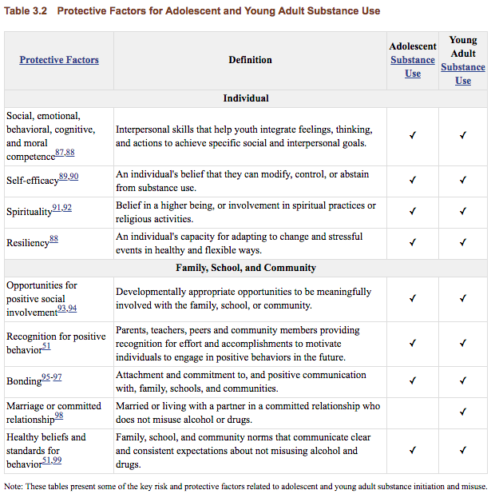

Setting the Context: Environmental Scan
As the basis for discussion about our future work products, Leadership Team members examined the Political, Economic, Demographic, and After School Field context we are currently in. The Environmental Scan is an essential requirement of a Mott Foundation Grant Proposal due on May 3rd, AND it is a productive vehicle to set context.

The completed Environmental Scan created during the meeting begins on the following page.

Environmental Scan

Political Considerations | General Trends | Opportunities | Threats
Some questions to consider:  - What is focus/messages of governor?  - What is focus/messages of legislature?  - What are the needs or issues of cities/counties?  - What are the trends and issues in school districts or education in general?  - Others? | • Governor Jerry Brown historically unwilling to approve increases to public funding focusing more on local control.  • Jerry Brown in last term and top two contenders for Governor include Lieutenant Governor Gavin Newsome and former LA Mayor Antonio Villaragosa.  • Legislature recently put forward a budget (approved by Jerry Brown) including a $50 million increase to the ASES program. CA3 is advocating for continued increases to the ASES program.  • K-12 focus on Common Core, Next Generation Science, and Local Control Funding Formula.  • CDE focus on continuous improvement and a movement toward Multi-Tiered Systems of Support is aligned with CQI requirement in after school.  • CDE recently released guideline/framework for Social Emotional Learning indicating more of a shift (back) toward a “whole child” approach. | • 2019-20 could see an influx of potentially available funding as a result of the passage of Prop. 64.  • Kevin McCarty a supporter of after school and is putting forward legislation to ensure that ASES and 21st CCLC Expanded Learning Programs would be eligible for the funding.  • Opportunity to assess some linkage or support of the work of CA Collaborative for Educational Excellence, a group supporting the rollout of new educational standards.  • Positioning expanded learning as a vehicle for teacher pathways, potentially offering a platform for 700 hours of pre-service-teaching hours and diversifying the teacher workforce.  • Providing tools and resources to empower parents, stakeholders, and expanded learning staff in the LCFF process.  • Change of political regime, and new superintendent of public instruction.  • Youth Voice and Leadership / Student activism and involvement (e.g., parkland students).  • Asset-based presentation to the public (benefits of investing in after school as opposed to “save after school.”  • Create relationships with new elected officials, candidates, and decision-makers.  • Increasing CAN’s position at funding and decision-maker tables. | • Treatment advocacy for Proposition 64 is strong and generally not supportive of prevention funding for proposition 64.  • Minimum wage continues to rise and therefore existing increase in funding will soon be negligible.  • Legislative fatigue of the expanded learning issue, or a sense that “you already got your increase.”  • Perception that the field is sustained because of existing $600 million investment.  • Federal funding at risk in Trump budget, but also CDE’s intel on the ground indicates there may be a reduction in 21st CCLC funding looming.  • Change of political regime and new superintendent of public instruction.  • Federal agenda to privatize education, increase school choice is a threat because 21st CCLC funding is low-hanging fruit to fund Trump/DeVos priorities.  • Administrative policy guided by government organizations not always research-based or data-driven.  • Current immigration and DACA debate is resulting in loss of staff, students/families.  • Lack of support for nutrition programs and SNAP at the Federal level could result in negative consequences for meal and snack funding, food stamps for families, etc.  • Significant increases in operational costs at school districts such as retirement and pensions (CalPERS). How are districts paying for significant increases in retirement and pensions.
Economic Conditions
Some questions to consider:  What are the economic conditions in your state regarding:  - Poverty rates/students receiving free/reduced lunch  - Unemployment  - State budget  - Needs for workers  - Drop outs/disengaged youth  - Median income etc.  - Others? | • 3,617,630 students, or 58.1% of students in CA are eligible for FRPM. This figure has remained pretty steady (between 58% and 59.4% since 2012-13).  • CA has a higher rate of Unemployment (4.9% in October 2017 according to the Bureau of Labor Statistics) than the national average (4.1%). California’s median income is $61,320 with huge variations regionally (e.g., silicon valley, LA, SF).  • Governor Jerry Brown proposed a budget in January 2018 $190.3 billion budget plan. The budget proposes $78.3 billion in K-12 education, or $12,076 per student, an increase of $4,600 per student over the 2011-12 levels. Also included in the proposal is a $5 billion investment into CA’s rainy day fund, anticipating CA’s next recession.  • CA has seen seven consecutive years of increasing graduation rates. For the class of 2016, the graduation rate was 83.2% | • CAN as a driving force to unify the field to increase funding, corporate, private, and government partnerships.  • Opportunity to position after school as an investment with ROI, saves communities revenue. Opportunity to message as important investment as opposed to/ in addition to the notion that after school needs to be saved.  • Stability of after school and summer.  • Position after school as a workforce vehicle, including creating the next generation of teachers, building workforce skills for participants.  • Opportunity to provide information, tools, and resources to increase knowledge/ ability for financial sustainability, partnerships, etc. | • Government chaos trickles down through the entire field, contracts, grants, etc.  • Unemployment rates decreasing results in increasing difficulties for programs to find and keep quality staff.  • Lack of program competency for financial sustainability. Need to build capacity in the field on how to increase program sustainability.
Demographic changes or issues
What trends are you seeing in your state regarding children and families? | • 6,228,235 enrolled in California public schools in 2016-17 (Ed Data). Approximately 13% of which are enrolled in California’s Expanded Learning Programs (CDE Expanded Learning).  • 47% of students in California are considered, “ethnically diverse” (Ed data). According to kidsdata.org 54% of California students are Hispanic/Latino, 24.1% are white, 8.9% are Asian/Asian American, 5.8% are African American/Black, 3.1% are multi-racial, 2.5% are Filipino, .6% are Native American, and .5% are Hawaiian/Pacific Islander.  • 1,332,405, or 42.8% of the state’s public school enrollment are English Learners (ELs). Of ELs, 1,107,214 are Spanish speakers. Spanish speakers make up the majority of English Learners in CA by far, followed most closely by the “all other” category (139,249), then Vietnamese (28,564), Mandarin (21,195), Arabic (18,713), and Filipino (17,470) (Ed Data).  • 37,693 students in California are Foster youth.  • The California Healthy Kids Survey has been measuring protective factors (caring relationships, high expectations, and opportunities for meaningful participation) in schools since 2004. All years of data surface a major discrepancy between Opportunities for Meaningful Participation and other Protective Factors (Caring Relationships and High Expectations). In all populations surveyed (Grades 5, 7, 9, 11) youth were most likely to score low (and least likely to score high) on indicators of Opportunities for Meaningful Participation. | • Support for English Learners as part of new assessment tool.
Afterschool Field
What trends are you seeing in your state regarding afterschool as a whole?  - Numbers of youth served in afterschool  - 21st CCLC  - School-age child care  - Other  - Staff  - Quality  - Perceptions/knowledge of afterschool  - Other? | • California ranked number one in after school by Afterschool Alliance’s most recent report America After 3pm examining access and parental satisfaction for after school nationally.  • California’s expanded learning infrastructure serves nearly 500,000 children and youth daily, and nearly 860,000 are enrolled in programs in CA.  • Expanded Learning programs serve over 75% of CA’s low-income (40% or more students eligible for FRPM).  • Schools with expanded learning programs have 80% FRPM (compared to 46% in schools without programs), and have 36.1% EL students compared to 14.7% for schools without programs.  • California allocates $1.1 billion to preschool programs, and $1.8 billion to support child  care for children ages 0 to 12. 40% of those children ages 0-12 supported by child care programs are in school-age care. According to the most recent data from the CDE’s Early Education and Support Division, at least 62,190 age 6 or over school-age children, as well as many school-age 5-year-olds, are served with child care funds through child care centers, family child care homes, and license exempt programs.  • Consistent lack of knowledge, especially at the site level, of quality standards and CQI requirements.  • Consistently high turnover. Recent data collected surfaced Site Coordinators surfaced a major need for qualified, motivated staff, many citing increased hours or pay an important factor. | • Increasing field sustainability by promoting the after school meals program by helping programs understand the benefits of supper program reimbursements going back into programs. Does surplus go back into school district general fund, FTEs?  • Increase public image of after school and expanded learning.  • Creating more K-12 and after school / expanded learning partnerships. Unification of school and after school.  • Increase corporate support and untraditional partners.  • Leveraging / messaging / increasing partnerships around expanded learning program role in creating the workforce of the future (e.g., STEM).  • Leverage new SEL movement / CDE Guidelines around SEL to focus on “whole child.”  • Build / strengthen advocacy infrastructures.  • Promote role of after school / and expanded learning to increase health. Increase partnerships / messaging around increasing physical and emotional health.  • Increase professionalism of the field.  • Afterschool for all | • Lack of funding and sustainability limits quality programs.  • Lack of funding and sustainability limits opportunities to recruit and retain quality staff, provide training, and adequate pay/hours.  • Existing funds get diverted (organizational and administrative costs) before reaching the kids.  • Clinical approach to after school.  • Not enough partnerships to reach local level.  • Insular field communications without enough public promotion of the importance of expanded learning, after school programs, and summer learning programs.  • New partnerships can create mission creep. Important to preserve the integrity and identity of after school.
Potential Organizations or Departments to Engage or Re-engage

This could add to your outreach potential or understanding opponents

Informing the CAN CDE Contract:
Jeff Davis set the context of the CDE Contract (pages 20 – 22 of the meeting materials packet). He shared his recommendations on the specific tasks to propose to CDE in the contract (pages 23 – 27 of the meeting materials packet) and invited Leaders to participate in a “gallery walk” activity where in small groups could reflect and comment on all tasks in the CDE Contract.

Following is the input of CAN Leaders:

Task 1: Task 2:

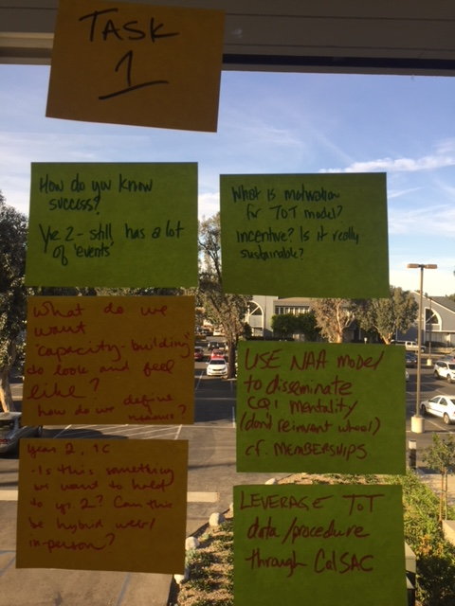
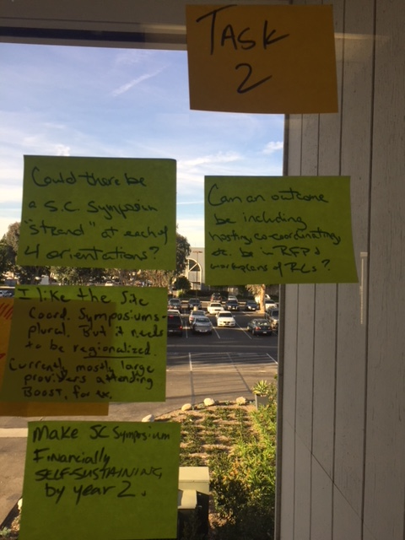

Task 3 – 4 Tasks 5 - 6

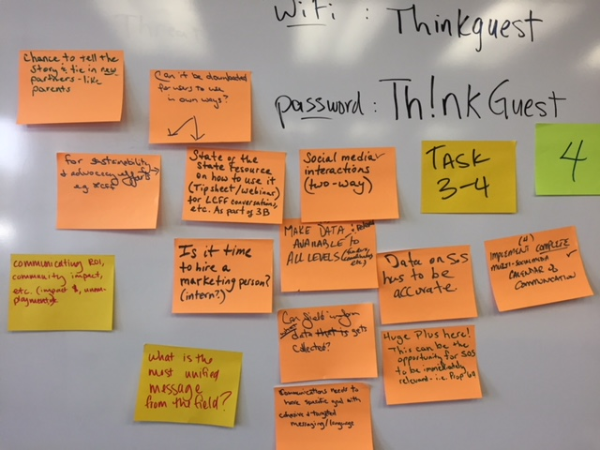
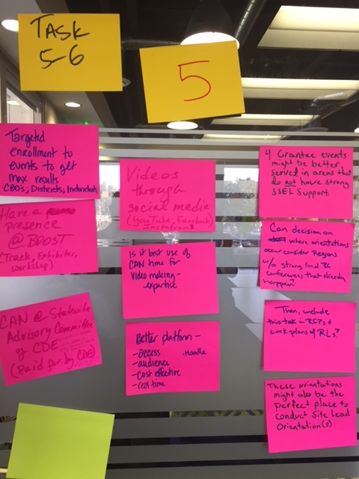

Summary of input to the CDE Contract
Following includes the exact language (and some refinement of the exact language or response to a question or comment). Stated in another way, non-bolded italicized statement in parenthesis indicates a paraphrase or refinement of LT input. Bold and italicized statements are a response (from Jeff) to a comment or question.

Task 1:  - How do you know success? (Provide a clear definition of success)  - What do we want “capacity building” to look and feel like? How do we define and measure? (Clarify the outcomes of capacity building and specific measures of success)  - Year two still has a lot of events.  - Year two 1C (web/ video-based training). Is this something we want to hold until year two? Can this be a hybrid web/in-person? (Consider web-based training as soon as possible. Create strategies in the task to utilize web-based training as part of in-person meetings, etc.)  - What is the motivation for ToT model? Incentive? Is it really sustainable? (Define incentives and sustainability strategies)  - Use NAA model to disseminate CQI mentality (e.g, memberships)  - Leverage ToT data procedure through CalSAC (current plans to leverage Bechtel project, if phase two is funded, to integrate into CalSAC ToT model and implement in partnership with CalSAC). | Task 2:  - Could there be a S.C. Symposium “strand” at each of the 4 Orientations? (Consider integration of orientation and Site Coordinator symposium. Conversations are taking place at the SSEL-level regarding how to have a more systemic approach to convening regionally and statewide between conferences, orientation, symposia, etc.)  - Can an outcome be including hosting, co-coordinating, etc. as part of Regional Lead workplans? (Consider stronger integration and collaboration with SSEL leads in the planning, implementation of a Symposium. Last years symposium was implemented with a planning committee of CDE, SSEL, and CAN. All three of those stakeholders also had a financial stake in the event.)  - I like the Site Coordinator Symposiums plural but it needs to be regionalized. Currently most large providers attend BOOST for example. (Build in ways to increase regional / local access to the Site Coordinator Symposium. Current plan is to rotate locations to increase access. There is not current organizational capacity or budget to accomplish multiple symposia in one year).  - Make SC Symposium financially sustainable by year two.
Task 3:  - Create a tip sheet or webinar on how best to use the State of the State, for example, in LCFF conversations, for sustainability efforts, for advocacy, etc. (part of 3B).  - Communicating ROI, community impact, etc. (impact $, unemployment, etc.). (Integrate community benefit and return on investment into data analysis)  - (Strengthen intentional dissemination strategies to) Make data available and relevant to all levels (funders, coordinators, etc.)  - Can the field inform what data gets collected? (currently informed by our Policy Committee Co-chairs, who also Co-chair CA3)  - Data on SoS has to be accurate.  - Huge plus here! This can be an opportunity for the SoS to be immediately relevant i.e. Prop 64. | Task 4:  - What is the most unified message from the field?  - Is it time to hire a marketing person (intern)?  - Two way social media interactions. (Create ways for CAN to implement two way social media conversations, respond to those that communicate with us through social media)  - Communications needs to have a specific goals with cohesive and targeted messaging and language.  - Implement a complete social media calendar of communication.  - Have a presence at BOOST (track, exhibitor, workshop)
Task 5:  - The four grantee events might be best served in areas that do not have strong SSEL support (e.g., Visalia versus Fresno, rural areas). Include in the work plans of those local RLs.  - Consider implementing orientations where regions do not currently have strong local SSEL-led conferences.  - Orientations might be the perfect place to conduct Site Lead Orientations.  - Create access to content through a better platform (e.g., online) to increase access, audience, cost-effectiveness, and allow users to access the content in real time/ their time.  - Is it best use of CAN time to create videos?  - Release videos through social media such as instagram, facebook, youtube to reach Site Coordinators.  - Target enrollment to events to get maximum results (CBO’s, Districts, Individuals). | Task 6:  - Include CAN participation at the advisory committee in the contract.  - Integrate into task 4 that CAN more actively publicize the advisory committee meetings.  - Create a vehicle for CAN to gather virtual “public comment” on particular agenda items of the advisory committee and share with the advisory committee.

Spectrum Vote on CDE Contract Items:
The Leadership Team was offered the opportunity to offer their vote on the elements proposed for the CDE Contract. Leaders had the opportunity to place themselves along a spectrum to outline their level of support for the CDE Contract elements moving forward. The spectrum options are outlined below.

1) Totally support these elements moving forward, absolutely no concerns;
2) While this is not perfect, it’s good and I support moving forward;
3) I have some concerns but will support moving forward;
4) I’m concerned but I could support if there were some additions/changes/considerations;
5) I am very concerned about the contract elements and unsure if I could support it moving forward

All members placed themselves on the spectrum in one, two, or three.

One member placed themselves on four and offered the following input:
One size does not fit all. Customized, targeted support needs to look different in different regions/ districts / and orgs. Suggest providing CAN/CDE training to local organizations who know their regions and can customize accordingly (site coordinator training, new grantee, CQI). Consider using an efficient technology platform such as moodle (to provide online training).

For Task four communications and marketing expertise / specialist is needed.

Mott Innovation Grant Proposal
Jeff outlined the context of the Mott innovation proposal outlined on page 32 of the Leadership Team materials packet. He proposed that CAN leverage their work in CQI and the development of new resources and commit to a three-year capacity building project around CQI that leverages a new assessment, CQI Guidebook, online data system, and capacity building model.

Discussion:
- Andi: It will be important for CAN to focus on building field capacity for sustainability. There is not adequate capacity to create sustainability within the field. We need to help the field with sustainability.
  - Jeff: This is consistent with advancing CQI grounded in the quality standards because sustainability is one of the twelve quality standards.
- Randy: Sustainability and fund development is important, and it is also important that we maintain the integrity of the field and are seeking strategies to be sustainable that also support the mission.
- Bruno: Consider focusing on communications and marketing strategies as part of the Mott Innovation Grant Proposal. Such a marketing strategy needs to extend beyond the to inform additional entities, uncommon stakeholders, those outside of our field why quality after school and summer programs matter.
  - Jeff: Possible to write some of this capacity into the budget.
- Andi: First Five has really strong communications and they have outlined the importance of early learning very clearly. Expanded learning, OST, after school and summer learning need a similar call to action. A strong, centralized, unifying message is needed to unite the field and promote the importance of the field to others. CAN could be a leader in this.
- Jason: What about leveraging LIAS? Is LIAS not similar to a unified message about what our field is and why it is important?
- Jason: Is it possible to leverage communication support from the Foundation Communication Team?
  - Jeff: Yes, limited support is included as part of Fiscal Sponsorship. However stronger messaging and communications strategizing would require additional investment.
- Normandie: Important to help the field/ programs develop new partners including business and corporate partners, additional local partnerships.
  - Jeff: Advancing partnerships is consistent with Quality Standard of Collaborative Partnerships.
- Rick: This focus on quality and this suite of tools can be utilized beyond ASES and 21st CCLC Programs. This can be used to expand into partnerships such as child care programs, other non-governmental organizations providing after school and summer learning.
  - Jeff: CAN has recently participated in conversations with the Early Education and Support Division and has shared the tools that are in development. The EESD staff that participate in CAN’s NCASE Project (see project update in materials packet) did verbalize the possibility of adopting Quality Standards for Expanded Learning for school age programs and leveraging the use of such a suite or resources. Therefore, developing a suite of resources is a potential avenue of engaging additional stakeholders outside of ASES and 21st CCLC programs.
- Jason asked for clarification of the proposal on the table from the CAN Director, is CAN seeking input on all the potential activities that may be included in the proposal?
- Jeff clarified that we were seeking the Leadership Team blessing to move forward with a “north star” for the grant proposal, which was consensus on the innovation that CAN would propose.
- Jason assessed whether the Leadership Team was prepared to vote on approving the innovation, and if so, sought a motion.
- Vote: Rick Rood motioned for the CAN Leadership Team to approve the proposal to move forward with CQI capacity building as CAN’s innovation.
  - Randy Mehrten seconded the motion.
    - Jason Riggs called the motion to a vote.
      - The motion passed unanimously.

Finance Committee Proposal:
Jeff and the Finance Committee provided context outlined in a Finance Committee materials packet provided separately. The Finance Committee is at a decision-point on what to utilize as it’s “customizable criteria” to determine “profitability.” Profitability in this context is a combination of financial profitability, but also how particular initiatives help CAN achieve its mission. This decision is important because it becomes the basis by which we as an organization determine the profitability of our initiatives, or the “return” in “return on investment.” This will be the basis of strategic decisions related to CAN fund development and sustainability planning for CAN.

The Finance Committee proposed the following items for customizable criteria:
1. Significant Unmet Need
2. Leverage

While some discussion about scale and community building being integrated or replacing other items, ultimately, the Leadership Team approved the Finance Committee’s proposal.

Closing

Next steps (see top of document) were summarized. A meeting evaluation was implemented and results will be shared with the Leadership Team.

