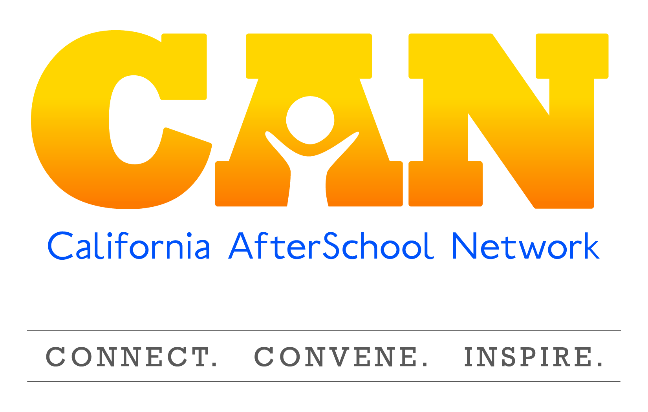

**Leadership Team Summary**

**June 11, 2015**

**Summary of Next steps**

**General next steps**

* LT Communication / update:
  + Send all recent information and documents (MOU, Bechtel proposal, Badges proposal, Mott proposal) to LT members with meeting summary and evaluation.
    - Future: create a centralized online platform for LT members to get all documents such as a Google group or drop box.
* Convene Committee Co-chairs over the summer.
  + Frank and Jeff develop game plan.
  + Tone – you are valued, there is transition, we support your work, but have limited capacity and have to focus on our funded deliverables.
  + Communication with the committee members – tools and resources for co-chairs.
  + What is happening between now and October, what is happening after October (what we know now).
  + How will we engage the co-chairs in that process.
* Field Communications
  + Jeff, Frank, and Darci craft a message to the field / listserv re: CAN transition to FCCC.
    - Through an intentional process of selection.
    - Funding to stabilize through the transition.
    - Leadership Team mobilizing, working with IED and TPM to continue to ensure stability, and ultimately sustainability through transition.
    - Can expect consistent communication
    - Status of Committee work
    - Tone – exciting, optimistic.
  + Message honoring and thanking Kelly with the language from the certificate, etc.

**Summary of Project-related next steps and Leadership Team decision-making Process**

**CDE Contract:**

1. Summarize input from today’s meeting as well as benefits to former flexible funding (task 4) for our meeting with CDE.
2. CAN CDE Contract Team meeting with CDE staff. CAN CDE team can share input generated from this meeting, gain understanding of content and process to create a concept paper based on meeting.
3. Share the content of the concept paper with the LT for rapid input and approval to move forward.
4. CAN CDE Contract team will create the proposal. Build on data about site lead consistency based on SRI data and the former workforce survey data.
5. Final contract content shared with LT for ultimate approval.

**Updating CAN Governance / LT roles and responsibilities**

* Darci, Frank, Jeff, Victoria (CAN Governance Team), Leverage BOARDSOURCE to surface a variety of comparable models.
* CAN Governance Team put forward multiple potential models for LT input.
* CAN Governance Team create draft roles and responsibilities based on LT input and discuss with LT via conference call.
* CAN Governance Team will incorporate LT input from the call into a final draft governance document.
* LT vote and adoption of new governance guidelines during q3 meeting.

**Executive Director recruitment and selection**

* Define roles and responsibilities of the search committee
* Solicit membership on the search committee
  + Create job description
  + Interview / screening process
* Bring top (one or two) candidate(s) to the LT, LT makes vote on new ED

**Leadership Team Co-Chair**

* Frank agreed to extend his term as Leadership Team Co-chair until June 30, 2016
* Nominating committee make a proposal on the format of the LT moving forward (e.g., is there one chair moving forward, or a process to select co-chairs).
* If necessary as recommended by the Nominating Committee and agreed upon by the LT, it will be Important to cultivate a new co-chair before June 30, 2016

**Packard Proposal**

* Jeff schedule team call with CAN Packard Team (Jeff Davis, Frank Escobar, Darci Smith).
* CAN Packard team will have a call with Ruth prior to Packard call to gain her expertise as a Packard grantee. CAN Packard Team might consider how to leverage Packard for general operating expenses, and how best to leverage a substantial Packard grant, as well as an organizational effectiveness grant.
* Report to LT on the result and input on moving forward.

**Develop CAN staff Job Description**

* Jeff get job descriptions (existing) PD, PC, Admin from UC Davis
* Darci work with Jeff to develop draft descriptions
* Share draft of descriptions with salary range with LT
* LT input
* Revise, finalize job descriptions based on LT input.

**Meeting Summary**

**Introduction**

The CAN Leadership Team welcomed Barbara Webster Hawkins from the Foundation of California Community Colleges (FCCC) to the Leadership Team as the fiscal sponsor representative. Darci Smith was welcomed as the Transition Project Manager funded through the S.D. Bechtel, Jr. Foundation. Frank Escobar acknowledged the critical role that Mary Jo Ginty has played in CAN’s transition and outlined how we would be celebrating her role and thanking her as part of the meeting.

**Leadership Team input to the CDE Proposal**

* Create an intentional tie-in to the Committee work within the CDE contract.
* **Task One:** Expand the target audiences within task one (Regional Triads and Site Coordinators) and ensure that grant managers and program directors are included in supporting systems of support continuous quality improvement. These systems should engage and support Site Coordinators to effectively implement a process of Continuous Quality Improvement.
* **Task One (or other):** The top recommendation of the Quality Committee is for CAN to convene statewide TA providers to share the recommendations on the rollout of quality standards and discuss potential cohesive, multi-organizational strategies.
* **Task Two:** Enhance the Site Lead Committee work. Move beyond a committee to understand the needs of Site Coordinators through focus groups. Create a small cohort of site coordinators that would develop an inspiring work plan to engage other site coordinators in future years. Engage existing CAN Committees and other potential partners in this work to ensure that this effort builds the capacity of participating site coordinators (benefit of participation) while applying that increased capacity to their work plan for the next year.
* **Task 3 (and 4)** – Beyond the creation of the State of the State of Expanded Learning, CAN should create a centralized hub for policy information how to beef up the dissemination strategy of the SOS to maximize the effectiveness of the document.
* Workforce
  + TA Landscape survey
  + How to recruit and retain
  + Leveraging volunteers to bolster workforce
  + How to connect to local WIBs.
* **What is missing?**
  + Space to be able to react nimbly to the field on emerging needs.
  + Support for Committee work.
    - Draw upon how we utilized task 4 funding.
    - How we push the flexibility – develop and nurture partnerships.
* **Future work:** Building off the K-12 integration and strategic partnerships – how to consider CAN as a vehicle to move forward. Partnerships tie with the Committee work – a clear deliverable to leverage those partnerships, convene the committees around partnership development.

**Governance**

**What stands out?**

* We are a collective, decision-making, action oriented entity. We are a constituent representation, not an association, but we must have strong representation from the diversity of the field.
* What is our role? Are we a board? We have to decide.

**Leadership Transition**

* Leadership Team roles and staffing are currently being established.
* We need to answer the question, where does the collaboration live? What kind of decision-making power does the collaboration have, or not have? Where does the buck stop if the work happens? What are the ingredients of continuity for our fiscal sponsorship model?

**Our steps and planning dynamics:**

* Must have clarity in our current context
* Then we focus our internal vision
* Outline barriers
* Then outline what you are going to do
* Then who is going to do it
* Then how do we reflect on how it’s working.

**CAN Governance Team (formerly Nominating Committee)**

* Creating recommendations on the appropriate roles and responsibilities of Leadership Team members. What is the Leadership Team, are we a non-profit board?
* What makes a Network unique and what is the best way to leverage a Network? What is the role of Leadership Team members, staff, etc. to maximize the effectiveness of the Network? How many members should that body contain, etc.?
* Hoping to have an ad-hoc. Nominating committee will anchor it, with an ad-hoc group.
* This group should gather some information from some external folks that have external knowledge.

**Understanding the role of the LT**

* Potential conflict of interest with entities at the table that might compete for funding with CAN.
* More room to clarify the role of personnel
* LT provides performance oversight for the ED.

**What we notice**

* Ownership, power of the Leadership Team
* Time to re-invent and become field led
* Opportunity to be a strong part of the system of support as the field is in disruption.
* Power of purse is now in the LT hands.
* Autonomy for organization and staff.
* Increased nimbleness
* Empowered the LT.
* Lack of funding is a challenge, but this provides an opportunity to go into it.

**Why does this matter?**

* Gives CAN the opportunity to maximize potential. The chains are released.
* Opportunity to respond to the context.
* Moving away from doing things to doing purposeful things.
* The Network has always been busy but not necessarily strategic.

**Sounds significant.**

* Need to develop new and emerging leaders.

**Major questions we should be investigating.**

* How do network committees work and how does it align to a common direction?
* What is the role of the LT, the reasonable amount of commitment?
* How do we focus our efforts on what matters most?
* What is CAN’s purpose, role in the field.
* What is the goal of the LT
* Where does CAN fit in the after school ecosystem?
* What is the role of the ED, what is the skillset of the person that we need?

**What effect will these changes have on the CAN LT governance?**

* Discipline in outlining unintended consequences of actions.
* Higher level of expectation and consistency, contribution, participation, depending on strength – how do we divide the role.
* That the LT has to define the structure, there could be different bodies that do different things, some could be advisory, some could be as sustainability, there must be clear roles and responsibilities of the different players, etc. ED is now responsible for the staff that works for them. Lead team is responsible for staff management.

**Which of these changes and shifts fit with the CAN mission and philosophy.**

* Of the field and for the field, by the field, with power of the purse.
* Of the field and for the field, biggest potential now.
* Collectively stepping up to participate, more LT investment, field investment.

**What new response do the changes call for from the LT?**

* More in tune with staffing and what is happening with operations
* Ownership of CAN
* Moving from CAN staff pushing the LT, now propelling the CAN staff forward.
* LT has to set and hold the direction.
* LT used to inform, but perhaps did not envision and have the pulse and bring the ideas to the LT.
* This means the Leadership Team must support the ED, but also hold them accountable. There is more of a balance of power. Collaborative approach that the LT empowers the Director, while holding to high expectation of the organization and what the field needs.
* Embody continuous improvement processes, with the LT as part of a reflective body that helps CAN continuously improve its impact.

**What do we need to do or consider to enable CAN to absorb these shifts**

* Consider the skills of the ED.
* Not try to do everything all at once, you can only do what you can do. Not trying to change everything in one year, be thoughtful about time and process and doing it right.
* Do we need to think about different funding sources?
* Think outside of the CDE universe. The gravity in CA turns this organization to ASES. It is worth thinking about child care, state association of YMCA’s, Boys and Girls, Rec and Park Departments. Other systems that CAN should think about leveraging outside of school based.
* THIS TABLE NEEDS TO LOOK MORE LIKE THE YOUTH THAT ARE BEING SERVED! Increase in ethnic diversity, cultural diversity. Reflect the field, the workforce, and the students.

**What kind of governing body are we moving forward?**

* Should not be a four meeting commitment with a bit of relationship brokering.
* How do we not burn people out?
* What programmatic committees do we have?
* What is the work that we want done and where does it best sit? Who does what?
* Want to have the ability to put aside personal or organizational agendas and be thoughtful about what CAN should do, or how it benefits the field in general.
* A collaborative point of the entire ecosystem.
* More decision-oriented around funding and personnel so there are some aspects of being a board.
* Big need of the LT on the direction of CAN. Are there any actions that prevent us from being informed by the field and taking field-appropriate actions? What is our representation that direction serve?
* Does participation in CAN present a conflict of interest for other organizations? What is the conflict of interest vs. collaboration? Are they there to advise direction or raise money for the organization?
* Anybody that participates has to have the ownership of your own time, makes it hard to participate when you don’t. This is also a barrier to committee participation. How do we address barriers to allow for rural, site coordinator participation, etc.

**Priorities for: Skills, roles, Responsibilities for ED.**

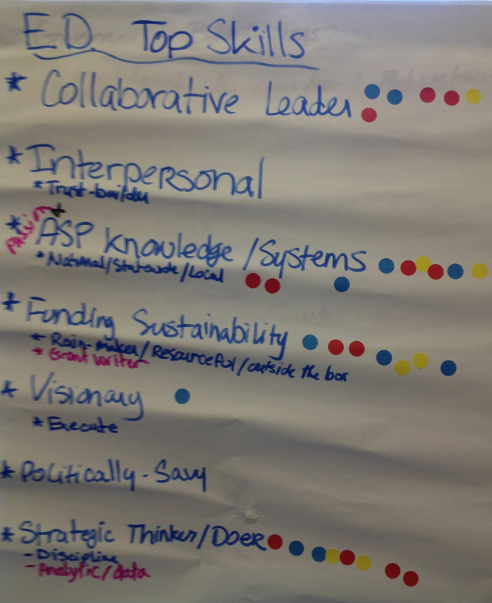

|  |  |
| --- | --- |
| **Skills** | **Votes** |
| Collaborator | 6 |
| Interpersonal |  |
| Knowledge of statewide expanded learning systems | 9 |
| Knowledge of statewide policy |  |
| Ensure sustainability, rainmaker, grant-developer | 7 |
| Visionary direction, thinker, mindset | 1 |
| Executer, demonstrate they can execute on a vision |  |
| Politically savvy |  |
| Strategic thinker / doer, disciplined, analytic | 8 |
| Communicator  *with high level, and field level, diverse stakeholders* | 1 |
| Social Justice / Equity mindset. *Understand power, privilege, and why Expanded Learning Programs are important to address* | 1 |
| Partnership Builder |  |

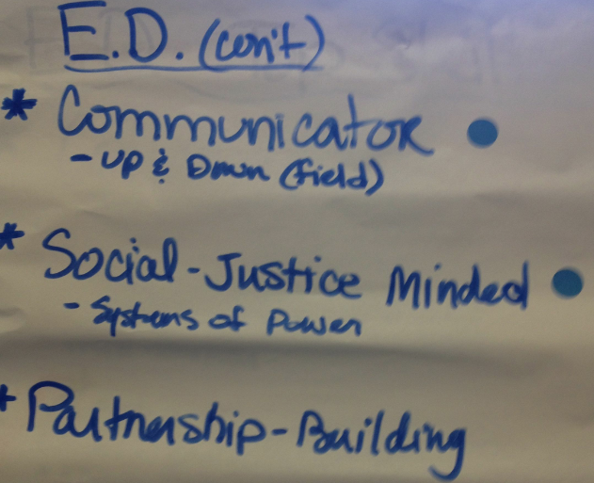

**Decision-making process for the LT in the interim**

The Leadership Team surfaced what key decisions they will need to make moving forward (see below) and outlined the next steps moving forward for making those decisions (see summary of next steps and major Leadership Team Decisions above).

What are the major decisions we need to make:

* CDE Contract
* Governance structure, roles, responsibilities, and commitments
* ED Selection
* Other staffing decisions
* Co-chair / leadership of the LT
* Leadership Team member recruitment
* Content of a proposal to Packard
* Committee Work – how we move forward.

**COMMITTEES**

* Communication to the field – CAN currently in transition. Some committees may continue if they have relevant work, others do not need to.
* Next step: Call with the co-chairs of the committee over the summer. Tone – you are valued, there is transition, we support your work, but have limited capacity and have to focus on our funded deliverables.
  + If we are going to “re-think” committees this has to be communicated as well.
* Review the spirit behind the intent of the infrastructure.
  + Past, CDE was not porous and CAN Committees were the only game in town. How do we adapt to the changing context.
* What if there were not committees? Does Mott care? How does current committee work look like in context of transition.
* Questions to address:
  + How do we gather, convene all the committee chairs?
  + What is the relationship of committees, co-chairs, and the LT?
  + Permission to go forth or decision to disband.
  + Revisit the origins of why we have committees. (how networks work)
  + Is committee the right word?
  + What has worked and doesn’t?
  + Is this something that we want to continue doing?
  + Do we have the right committees?
  + What is the committee structure?
  + What are reasonable expectations of committee members?
  + What is the difference between a committee member and a work group member, what do they do?
  + How do we create equity among committees?
  + How do we fund committees?
  + How do committee co-chairs function as a group of leaders and community of practice to maximize committee work?
  + Revive the annual committee retreat.

Idea presented by Michael

Approach the EL and Migrant Ed for a substantive process and product that could be developed in conjunction with the EL Committee.

**What worked about our meeting?**

* Open, transparent, collaborative
* Hard work, good work
* Reflection that smaller group is operating smoother. With really intense work moving forward it may be something to consider. Chemistry is good. Collegial relationships. Authenticity. Positive attitude.

Did not work

* 9-5 too long – go back to 10-3 model.

Attendees:

Jhumpa Bhattacharya

Sandra Birmingham

Tia Dwyer

Michael Funk

Jessica Gunderson

Jeff Hamlin

Ruth Obel-Jorgenson

Stu Semigran

Co-Chair: Frank Escobar

Fiscal Sponsor: Barbara Webster Hawkins

Transition Project Manager: Darci Smith

CAN Staff: Jeff Davis, Kelly Faustino