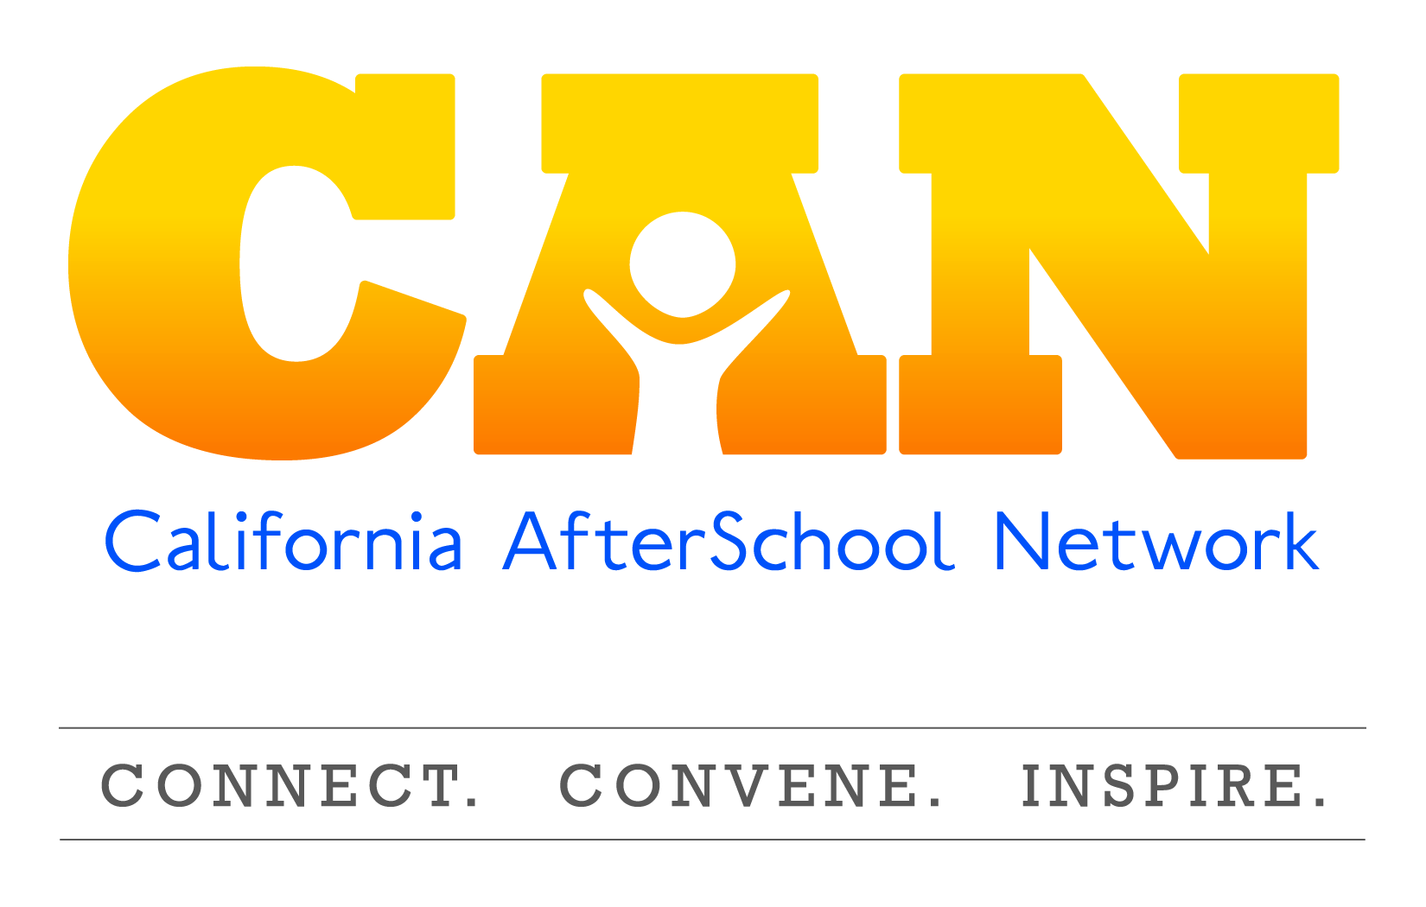

Name of Action Team:
Nutrition and Physical Activity Action Team

Goal of NuPA Action Team:  The Nutrition and Physical Activity (NuPA) Action Team provides a forum for individuals and organizations that are committed to expanding nutrition and physical activity programs, policies and services in expanded learning programs. | CAN’s Mission:  To provide professionals, advocates, and community members the tools and resources necessary to build high-quality out-of-school time programs in California.
Objective #1
By January 2018, the NuPA action team will have
disseminated the first quarterly Newsletter and webinar of 2018.

Activities include, but are not limited to: | Notes:
- Research potential webinar candidates to be showcased on the quarterly newsletter  - Create webinar rubric and guidelines for presentation creation  - Host and record webinar sessions | - Quarterly newsletter will be released in January, April, July, and October  - This workgroup will operate on an ongoing basis and meet as needed, and decided on by the committee
Objective #2
By March 2018, the action team will have created and submitted
an issue brief around NuPA for the State of the State of Expanded Learning in California.

Activities include, but are not limited to: | Notes:
- Membership to this workgroup is through recruitment only. Should you be selected to participate in this workgroup, the NuPA Planning Committee will reach out to you with membership details. | N/A
Objective #3
By June 2018, the action will have redesigned the NuPA webpage
into a new, user friendly and accessible platform of resources for the OST field.

Activities include, but are not limited to: | Notes:
- Assessment and elimination of current website content  - Creation of CAN NuPA webpage layout, content, archiving process, etc.  - Continuous updates of resources, policy updates, web libraries, funding and professional development opportunities | - This workgroup will operate on an ongoing basis and meet as needed, and decided on by the committee.
Objective #4
By September 2018, the NuPA action team will have created a Healthy Choices
and Behaviors workshop to be submitted for presentation at the 2019 BOOST Conference.

Activities include, but are not limited to: | Notes:
- Develop title, outline/overview, internal agenda and powerpoint for workshop  - Creation of an activities packet for dissemination  - Potential for facilitation at BOOST conference, or regional symposiums on the Action Teams behalf | - RFP deadline for BOOST conference: September 2018  - This workgroup will operate on an ongoing basis and meet as needed, and decided on by the committee.

There are two primary ways that stakeholders and the field can participate in the California AfterSchool Network Action Teams. They are not mutually exclusive, and each carries specific levels of benefits and responsibilities.
Subscribers
Network subscribers receive free access to information regarding current after school policy, funding opportunities, resources to build quality, as well as current after school news, events, and research all through the CAN Newsletter, social media, and website.
Members
Network members actively participate in CAN Action Teams and Workgroup activities. Members represent the voice of the field and inform Network staff regarding CAN’s efforts to address out-of-school time issues and concerns, and work collectively to achieve specific objectives within each Action Team’s or Workgroup’s work plan. Members receive the benefits of subscribers as well as opportunities for networking, collaborative work plan implementation, and resource sharing around common areas of interest. Members secure their commitment by signing an Action Team or Workgroup member commitment agreement that details the specific expectations of the Action Team or Workgroup they are joining.

Commitment Agreement
Action Team or Workgroup members make a commitment to attend 66% of all scheduled action team workgroup meetings, and commit to Action Team and Workgroup efforts between meetings as defined by each Action Team or Workgroup. Action Team or Workgroup members commit to support a one-year work plan with specific objectives and are free to continue for subsequent years without term limit.

