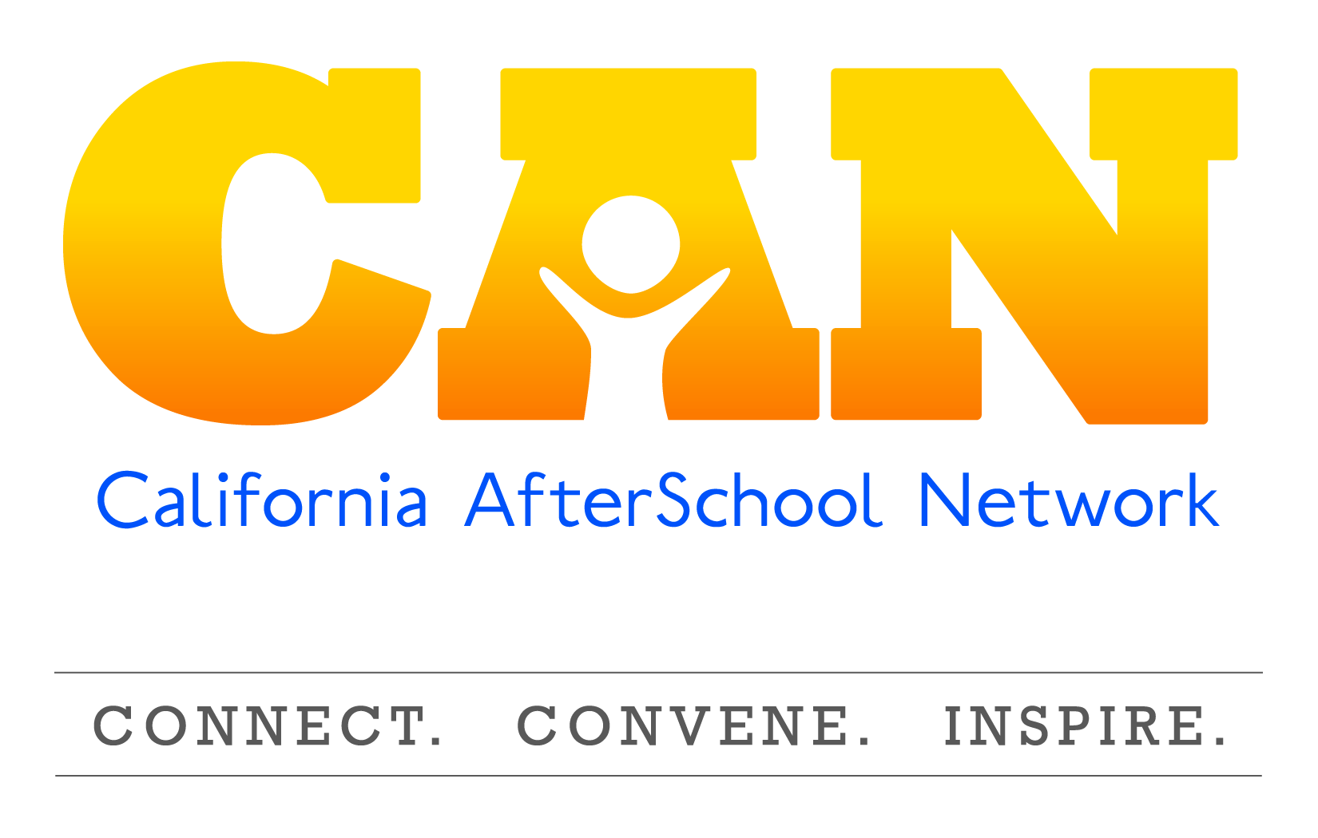
Policy Committee Meeting Summary
June 16, 2015

Speakers:
- Jessica Gunderson, Policy Director for the Partnership For Children and Youth
- Brian Lee, State Director for Fight Crime, Invest in Kids CA
- Erik Peterson: Vice President, Policy, Afterschool Alliance

ASES Increase Policy Update

Senate Bill 645
- In February, PCY conducted a survey with over 600 responses.
  - Over 90% indicated that their ASES program had been negatively impacted by the stagnant funding.
  - Items that were getting cut were: staffing, inability to retain high-quality staff, and offering professional development for staff.
- Access all of the survey results from the survey administered by the Partnership for Children and Youth here
- Rate increase effort has been a two pronged approach: moving it though the budget process and the legislative process

Budget Effort
  - Governor released his budget in the beginning of January and did not include any increase for After School Education and Safety (ASES)
  - In the May revise, there was not any additional money for ASES
  - After the May Revise comes out, both Assembly and Senate developed their own budgets. On both sides there is a sub committee for education. On the Assembly side, they have gotten traction with the education sub committee
- The chair of the sub-committee, Assembly member Kevin McCarty, (representing the Sacramento Area) said this is a priority
  - When they were developing their final budgets, the Assembly put 50 million to cover a dollar increase for ASES
  - At that time, the Senate budget did not include any increase for ASES (end of May)
  - The next step in the budget process is for the Budget conference committees of the two houses meet to resolve differences.
- They develop a legislative budget--this is known as the budget conference committee.
- The two houses compromised to include 25 million dollars which would result in a $.50 increase to the ASES daily rate
  - Monday, 6/15, the two houses voted on the final budget which included 25 million to ASES.
  - Last step of the budget process, which is the governors finalization/signature of the final budget. Governor has final veto power on various items on the budget (blue penciling)
  - This has been a concerted effort from the field. The Legislature has received hundreds of letters from the field advocating for the increase.

Legislative Effort
- Introduced by Senator Hancock, who represents the Oakland/ Berkeley areas
- Sought to increases ASES daily rate by $1 (2 $.50 increases over 2 years) and included a Cost of Living Adjustment (COLA)
- This bill is still alive and has passed the Senate Education Committee, the Senate Appropriates Committee and the Senate Floor
- Bill is currently in the Assembly and yet to be sent to a Policy Committee
- The language that is currently in the bill is not the same language that was in there when it was first introduced
  - Has been cut significantly to read that if the legislature appropriates new money that the minimum and maximum grants can be adjusted by the CDE
  - Doesn’t have any language around the COLA
  - Doesn’t have authorization for an increased rate
  - Very technical and minor, but this is a vehicle that is alive and moving

Other Budget Items
- There is a lot of money for education in the budget and more money than they originally expected in January for LCAP (which local districts have discretion over)
- Having also been following child care because hundreds of thousands of students are served through a child care subsidy system (primarily a voucher system).
  - They lost close to a billion dollars over a seven-year period and are slowly trying to get some of that back
  - Legislature is putting hundreds of millions of dollars into childcare and preschool that the Governor cautioned that we don’t necessarily have the resources to do
  - That does impact after school care, because about ½ of the childcare slots do go to school age care
  - There are currently 12,000 voucher slots that the legislature has proposed increasing as well as an increased reimbursement rate
  - Is after school competing with childcare?
    - No, child care primarily comes out of the general fund while After school comes out of Prop 98 fund (that is money set aside years ago)

Assembly Bill 706
- Introduced by Susan Bonilla in West Contra Costa
- Establishes a California AmeriCorps with a focus on STEM
  - Seek to bring more STEM education programs to schools, after schools, and community based organizations
- Would be administered by the CA volunteer Corps
- CA version of AmeriCorps with a focus on STEM that could serve public entities or non profits
- Amendments:
  - Focus specifically on expanded learning as a key entity that would be served
  - Lowered age to applicants to 18
  - Added language that this wouldn’t go into effect unless it was connected to something in the budget
- Currently, there has been a lot of support for this bill. This bill has made it out of the house of origin and has moved to Senate Government Organization Committee
  - Committee meeting is 7/14 at 9:30 in room 4203.

Assembly Bill 891
- Introduced by Assembly member Nora Campos, who represents the San Jose area
- Sponsored by Children’s Defense fund and by Western Center for Law and Poverty
- This bill gives first priority enrollment in ASES programs to:
  - Homeless youth get first priority for programs at all sites
  - Pupils enrolled in Cal Works assistance second priority
  - Pupils that attend the program on a daily basis third priority
- This bill has language clarifying that programs cannot charge family fees and that programs cannot conduct individual eligibility determination based off of need or income
- Passed out of the Assembly Education but was held on suspense on appropriations
- This will not be moving through the legislative process, but it is a two-year bill so it can go through the process next year

Senate Bill 403
- Introduced by Senator Carol Liu representing the Pasadena area
- Defines what community schools are and includes a provision around after school programs in their definition of community school
  - States that if and when money becomes available in the future, it would make grants for community schools
  - Requires department of education to provide technical assistance to school districts around the development and operation of community schools
  - This bill would also require the department of education to develop a report for the legislation around the formation and operation of community schools. After schools would be a key component in that.
  - Referred to possible grants for LEAS for the formation and support of community schools
  - Healthy Start was a program that supported community schools and had coordination with expanded learning. This bill looks similar to that
  - Held in senate appropriations—will not be moving forward. Could possibly move forward in upcoming cycle.

LCFF/ LCAP Process
- Local Control Funding Formula (LCFF) and Local Control Accountability Plan (LCAP) is 3 year local accountability plan that every district and County Office of Education (COE) has to do
- Last year was the first time that districts/ COE had to complete
- After school got mentioned a lot in the plans but didn’t get a lot of money to help support them.
- Going into the second year, they are required by law to have an annual update that is due by July 1st
  - This update will identifies progress, changes, and identify what they will do with the additional money that was in the budget
- There is currently a broader discussion related to state decisions about the evaluation rubrics and how districts and COE will be evaluated
  - SBE staff are working diligently, setting state standards, setting performance goals, etc.
  - This lays the groundwork on what they should be accomplishing with their LCAP
  - This process is going slower than anticipated (supposed to be completed by October 1st). May expand deadline to ensure it is done right
  - UPDATE POST-CALL: Deadline extended 1 year to October 1, 2016
  - What does this mean for after school programs?
    - Unknown at this time, but it could be an incentive to invest in after school programs, particularly because of the alignment with the priority goals established by law (student achievement, student engagement, etc.).
- When the legislative analyst office and department of finance have been asked about the ASES increase, the response has been that increasing the ASES reimbursement rate should be part of the LCFF because it is the role of the locals to make this a priority.
- Participant Comment: LCFF is considered the answer to all money issues which is forcing school boards to identify goals and priorities. They are struggling with framing those discussions.

Questions:
- What’s the likelihood ASES budget increase will be supported by the Governor?
  - Issues to consider: department of finance (oversees finance for the state) did not support the ASES increase in multiple budget hearings.
  - A common response is: If a district wants to increase the daily rate, it should come from the LCFF (Local Control Funding Formula) dollars
  - Generally speaking, Governor has not supported categorical programs, he has made a lot of changes in education and other areas of government
  - Governor and Legislature has different projected revenues
    - Legislator has projected about 2 Billion more than the Governor. Need to agree on the total package before they can dig deeper on the line items.
  - Timing—needed to be signed by July 1st.
    - According to Sac Bee and Governors website, the Governor will be holding a press conference today (6/16) at 1:30.
    - We may not find out if the Governor has increased the ASES increase for the next couple of days.
- Is there any updates about the ASES cohort renewals?
  - CDE has said that they will not be posting ASES renewals
  - CDE send out a letter at the end of April to all agencies renewing letting them know that they were renewed and to expect the Ao400 letter at the end of this month
  - Torlakson’s office has released a press bulletin identifying 67 new programs that have received ASES funding. Access the list here
- Would the 25 million increase for ASES be just for one year and after that it would go back to the original amount?
  - It is a presumption that if there is an increase, it would be increased on an ongoing basis
  - The budget is always one years funding, but unless it states that it is only one years funding, it is usually rolled in the following years.
- If the governor were to line item veto the ASES increase, could you amend the Hancock bill by putting in the other pieces, including COLA?
  - The bill could not be amended to include the dollar increase. The only reason it was able to get off of the suspense file is because it was at a certain amount. If your bill costs more than the allotted amount, then you have to do some amendments to get it off of the suspense file.
  - It wouldn’t have made it though the process with that price tag.
  - COLA might be able to be considered to incorporate, but once you amend language in one house, you cannot put language back in there for the other house.
  - Generally, it is hard to get significant budget dollars into a bill.

BREAKING NEWS AT END OF THE CALL: Reportedly, the $25 million ASES increase unfortunately did not make it into the final budget agreement

Federal Updates
- 21st CCLC
- Childcare Development Block Grant
- Elementary Secondary Education Act
- HR5

21st Century Community Learning Centers (CCLC)
- The House of Representatives has not marked off or passed the labor HHS appropriations spending bill that covers health and human services, Department of Labor, Department of Education, and related agencies (i.e.- Corporation for National Community Services)
  - House hasn’t marked one up in 3-4 years at sub committee level
  - Should be marked up tomorrow at the sub committee level
- Bad news: Due to sever budget caps, we are expecting cuts on many programs included in this bill.
  - Department of Education has 3 billion dollars in cuts
    - More cuts than in 2013 with the sequester
  - 19 program shave been eliminated including some key after school programs, like:
    - School improvement grants
    - Caroline White PEP grants (physical activity grants)
    - Investment innovation (OST use to scale up)
  - In addition to the 19 programs eliminated, 12 programs sought cuts
- Good news: 21st CCLC appears to be level funded
  - The tables are not out yet that has the individual funding streams, but it appears that 21st CCLC will be funded the same as last year at 1.15 billion
  - In addition, there is language talks about the need for Department of Education to prohibit 21st CCLC funds to add time to school day, school week or school year
  - This is the republican response to the waivers

Child Care Development Block grant

- Last year, this grant was reauthorized and level funded
- This year, asking for Substantial increase by advocates and the President
- A couple of increases on HHS including Head Start
- Pre-school development grants were eliminated
  - This will be very damaging to children and families
- Policy watchers don’t believe it will get very far
- The Mark Up will be webcast will be 6/17 at 9:00am EST. This will be very contentious, however most of the most of the sub committee mark up have not been very contentious
- Not sure this bill is going to make it to the full committee, so Democrats will be offering a lot of amendments to bring more investments to child care programs
- There are a number of policy writers around HHS, to make it such that it won’t get much support from the minority party
- Spending process overall:
  - President will veto spending measures that don’t treat defense and non defense discretionary funding equally
  - This hasn’t been the case so far with House and Senate bills. There has been increases in defense at the expense of non defense which leads people to believe that these will be vetoed
- Senate side:
  - Haven’t seen a bill yet from the Senate labor HHS committee, but they will put bill out early next week for mark up
  - The strategy from the Senate side has been articulated by democrats to prevent any spending bill to get to senate floor. They haven’t had a chance yet to show they are able to do this.
    - This is another reason why these bills won’t make it.
- House side:
  - Full mark up is expected next week but most likely after July 4th recess.

Every Child Achieves Act
- This is a bi-partisan bill that is chaired by Alexander and Murray
- There have been a lot of false alarms in terms of when this bill will go to the Senate Floor. Will see a vote late this week and on the senate floor next week (It could be bounced back after the recess)
- More than a week to go through amendments, open amendment process
- Amendments:
  - Adds environmental literacy as a use
  - Community schools: Would allow support for title one schools to integrate a comprehensive community school
  - Includes a Full community school program
  - Title 4 block grant: allow a community school coordinator as an allowable use

HR 5: Student Success Act
- Eliminates Title 4 and replaces it with the Local Academic Flexible grant
  - The $1.15 billion that is currently going to 21st CCLC would go to the Local Academic Flexible grant
  - This grant flows funds based on the amount of low income students by state—each state gets an allotment
- Went through for debate and was pulled from a vote in February, could possibly come back on the House floor any time
  - The thought is that the votes are there now with three new amendments.
  - Votes will probably fail but it will allow it to move forward
  - This bill would eliminate 21st CCLC, no bi-partisan support.
- Amendment:
  - Title One Portability-less federal control and ask states to control (not supported by the chairman)

Administrative Updates:
- Grantees that have 21st Century funds have traditionally received email from West Ed to complete Annual Performance Review.
  - West Ed contract is no longer in effect. New company is not in effect so don’t expect evaluation until September.
- Statewide evaluation (is due for ASES, ASSETs, & 21st CCLC) have been sent out and are due in October.

Just In:
- Funding did not survive negotiations (HAS NOT BEEN CONFIRMED)

Resources:
- Leg Info
- Afterschool Alliance
- Jessica Gunderson: jessica@partnerforchildren.org
- Brian Lee: blee@calfightcrime.org
- Erik Peterson: epeterson@afterschoolalliance.org
- Further questions may be clarified by visiting: http://capwiz.com/afterschool/issues/bills/
- Updated Policy News: http://www.afterschoolalliance.org/policyFedNewsArchive.cfm

