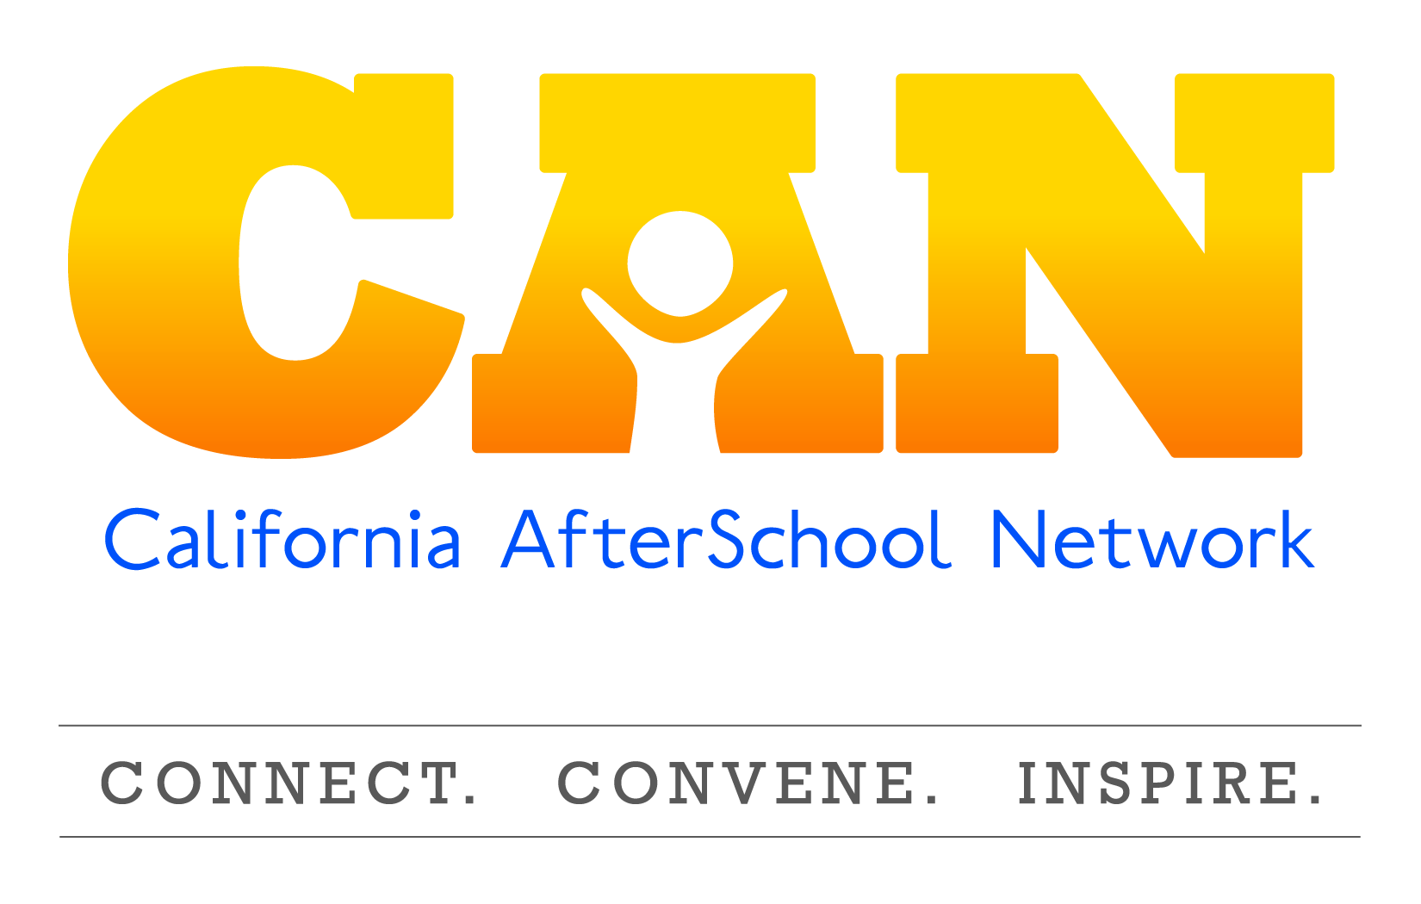
Policy Committee Meeting Summary
March 4, 2015

Speakers:
- Jessica Gunderson, Policy Director for the Partnership For Children and Youth
- Erik Peterson: Vice President, Policy, Afterschool Alliance

State Budget Update

Overview
- General timeframe for State Budget process (January – June)
  - Governor releases his budget in the beginning of January
  - In May, a revised budget is released with updated estimates of state revenues
  - Budget should be agreed upon by legislature and the governor by June 15.
- Budget was released Jan 9th with higher revenues than expected.
  - Governors budget continues to have a prudent spending package, not including restorations in child care or health and human services
  - Limited new funding was primarily focused on education
    - Eliminated all remaining school deferrals
    - Reduced mandate backlog for schools
    - Provided final payment for School Facility Repair Program
    - Increased LCFF payout by $4 billion (does not provide additional funding, but does close the gap that schools expect to be paid by the implementation of 2019-20)
    - Overall, Proposition 98 spending was by $7.8 billion
    - There were no increases to ASES
    - As state income taxes come in, the projection are expected to be significantly higher, resulting in an ever larger budget for education across the board
    - Minimal increases to school childcare and early learning in the formulas and cost of living
      - There were not the restorations that were expected based on the increased revenues at the state levels.

State Legislative Update

- Last Friday was the deadline for bill introduction.
- PCY and other state organizations are in the process for reviewing hundreds of bills
- PCY will provide a more comprehensive list in the coming months
- Starts in February, committee process starts in March and runs through September

Senate Bill 645
- Introduced by Senator Hancock, who represents the Oakland/ Berkeley areas
- Increases ASES daily rate over 2 years.
  - This would include two 50-cent increases.
  - Moving the daily rate from $7.50- $8.00.
    - This would be a $54 million dollar increase on top of the 550 million investment existing
    - An additional 50 cent increase in the out years would bring the rate to $8.50, which would increase the investment by 72 million dollars
- This bill also includes as a cost of living increase based on the rising cost of doing business for ASES Program
- Sponsored for California After School Coalition
- PCY administered a survey regarding the impact on not increasing the rate and received over 550 responses from the field.
  - Will analyze and share out the survey results

Assembly Bill 891
- Introduced by Assembly member Nora Campos, who represents the San Jose area
- This bill gives first priority enrollment in ASES programs to:
  - Homeless youth get first priority for programs at all sites
  - Pupils enrolled in Cal Works assistance second priority
  - Pupils that attend the program on a daily basis third priority
- This bill also has a provision around providing transportation to and from school to the targeted populations
  - It is unclear how this transportation would be paid for
- Sponsored by Western Center for Law and Poverty

Senate Bill 403
- Introduced by Senator Carol Liu representing the Pasadena area
- Defines what community schools are and includes a provision around after school programs in their definition of community school
  - States that if and when money becomes available in the future, it would make grants for community schools
  - Requires department of education to provide technical assistance to school districts around the development and operation of community schools
  - This bill would also require the department of education to develop a report for the legislation around the formation and operation of community schools. After schools would be a key component in that.

Assembly Bill 706
- Introduced by Susan Bonilla in West Contra Costa
- Establishes a California AmeriCorps with a focus on STEM
  - Seek to bring more STEM education programs to schools, after schools, and community based organizations

Questions:
- AB 891: Looking at the priority enrollment and transportation for ASES, is that just for those identified populations or for the whole program?
  - As it is written right now, it is just for the priority populations. It is unclear now who would be funding the transportation.
- SB 645: Since there will be a 72 million dollar fiscal impact at the state level, what the support for this bill/likelihood of it passing?
  - The after school field has been advocating for an increase for a long time. This field has held out on asking for more money for 9 years where other educational programs are asking for additional funds on a regular basis.
  - There is going to be a budget strategy and a bill strategy to ensure that there is a budget request for that amount of money.
  - There is a need for this and it is evident in the survey results
  - There will be competing priorities,
  - When there was a recession between 2009-2012, ASES wasn’t touched and a lot of programs were hit significantly. Some programs are trying to get back to where they were 6 years ago. However, you can’t pay the same amount as you did 10 years ago (i.e.- personal, building costs, etc.).
- SB 403: If after school programs were able to be considered as part of the community schools definition, would they be able eligible to receive the federal funding and grants out there for community schools?
  - Unsure, have to check in with their office
  - If it is similar to Healthy Start, these types of grants can go to multiple parties, but usually there is one fiscal agent.
  - There could be the potential for this based off of the federal funding they are modeling this after.

Federal Updates

House of Representatives
- Elementary Secondary Education Act, previously No Child Left Behind in 2001, authorized for five years, has now moved onto the waiver process with the Department of Education because its not currently working in many respects
- This past congress (113th) passed a bill: HR 5, supported by Republicans and opposed by Democrats.

HR 5: Student Success Act
- Continues to allow title one funds to help support after school and summer learning
- Eliminates Title 4 and replaces it with the Local Academic Flexible grant
  - The $1.15 billion that is currently going to 21st CCLC will now go to the Local Academic Flexible grant
  - This grant flows funds based on the amount of low income students by state—each state gets an allotment
  - At the state level— these funds are disseminated by competition:
- 75% of the funds can go to school districts,
- 10% can go to private enterprise (for profit, non profit, other entities)
- 15% stays with the state education agency to be used for assessment, accountability, etc.
  - The big difference of the Local Academic flexible grant mandates districts/ CBO’s, etc. to provide evidence of increased academic achievement
    - Long list of allowable uses, including after school, in school activities, education technology, subject specific activities, etc.
  - One of the negotiations was to add student engagement in addition to academic achievement and that other agencies such as colleges and universities and local government can apply under that 10%
  - Passed in committee, went to the house floor
    - Amendment proposed by Congressman Barletta requires school districts to report how much of their Title 1 funds are being utilized for after school or summer learning programs passed by unanimous vote
      - Serves as a way to show need for dedicated funding for school-time programs
    - Under review, the Bill did not pass due to resistance from conservatives, but policymakers are trying to get it back into the House for re-review and re-vote
      - There is some opposition from conservative action groups who believe that bill places too much emphasis on the federal government

Senate
- There have been various leadership changes within Senate
  - New committee chairman, Chairman Alexander from Tennessee has previously been a Secretary of Education as well as a governor, so he is able to bring forward extensive education experience
  - New ranking member, Democrat Patty Murray from Washington
- Draft bill as a proposal by Chairman Alexander in mid-late January:
  - Title 1 is unclear whether or not after school would be funded or not not explicitly mentioned, but implies will remain the same
  - Title 2 mentions after school with teacher professional development and planning. Currently there is a block grant for this, stating that after school is an allowable use
      - Title 4- Eliminates 21st CCLC and replaces it with a block grant called: Safe and Healthy Students
    - Focus is on supporting the whole child, in and out of school
    - Focus is mental health support, fiscal education and other factors to student success in addition to academics
    - Appropriates at 1. 6 billion (higher than 21st CCLC)
        - Based on formula of low income students by state, every state gets an amount
        - The grant is allotted by formula, not by competition:
          - 2% held by state for administrative purposes
          - 98% go directly to school districts based on the number of low income students in district
    - Language where school district is allowed to partner, but does not provide detail nor incentive to do so
    - Districts will complete a needs assessment around student supports, working with community, parents, and school itself to figure out among the 9 allowable uses make the most sense for their students (includes before and after school, summer learning, mental health services, school counseling, suicide prevention, drug and alcohol abuse prevention, mentoring, physical education, positive behavior interventions systems)
          - After assessment, they report back to the state what they plan on doing with the money
- There are various concerns from the field regarding bill:
  - Funding differs greatly from 21st CCLC – doesn’t encourage school and CBO partnerships. All funds would go to school districts.
  - Pitting needs of students in school (i.e.- counselor at every school) against after school programs
  - Loss of state support. Currently the 21st Century allows states to hold back a % of the funds to provide professional development, training and other which helps improve the quality nation wide
- 21st CCLC and the after school piece has been part of the conversation. There has been a great deal of advocacy for after school funding and the need for this in the last 15 years. Both parties want to continue to support CBO’s and after school programs through grants and the federal investment.
- In the draft bill from Murray and Alexander, there is a good chance to have language around 21st CCLC and community support.

Appropriations/ Budget:
- FY 16 starting now with Presidents proposed request, budget submitted in early February
- FY 16 president proposed level funding for 21st CCLC 1.15 billion
  - Childcare development broad increase
  - Other childcare tax credit proposals
  - 3/4 was the first hearing
  - Level funding as last year, possible to have a small increase this year
  - Sequester cuts come back into the picture for FY 16. President budget ignored sequester cuts 6-7% cut
  - Senate hasn’t started appropriations process

•Further questions may be clarified by visiting: http://capwiz.com/afterschool/issues/bills/
•Updated Policy News: http://www.afterschoolalliance.org/policyFedNewsArchive.cfm

Federal Budget Updates
- FY 16 Budget appropriations set to begin now with the President’s proposed request in early February
  - Proposed level funding with last year’s funding in 21st CCLC ($1.15 billion)
  - Childcare Development Block Grant received broad increase
  - Hearings included various mentions about need to continue to fund after school
  - FY 16 first year where sequester cuts come back into the picture

LCFF/LCAP Updates
- State board of education approved a new LCAP template in November
- Can be found on West Ed website or state board website
- School districts are now in the process of creating the annual LCAP update due June 30, 2015
  - Creation of the LCFF rubric is the document that would be used by COE’s to evaluate and review the information in the districts local control accountability’s plan
    - West Ed has been contracted to create rubric, first draft released January. Updated rubric released last week.
    - Next state board of education meeting is on March 11-12 a lot of discussions around LCFF rubric

Announcements:
- Cal Sac Challenge—May 11-12
- Next Policy Committee Update: Wednesday, June 24th at 11:00 A.M.

Resources:
- Leg Info
- Afterschool Alliance
- Jessica Gunderson: jessica@partnerforchildren.org
- Erik Peterson: epeterson@afterschoolalliance.org

