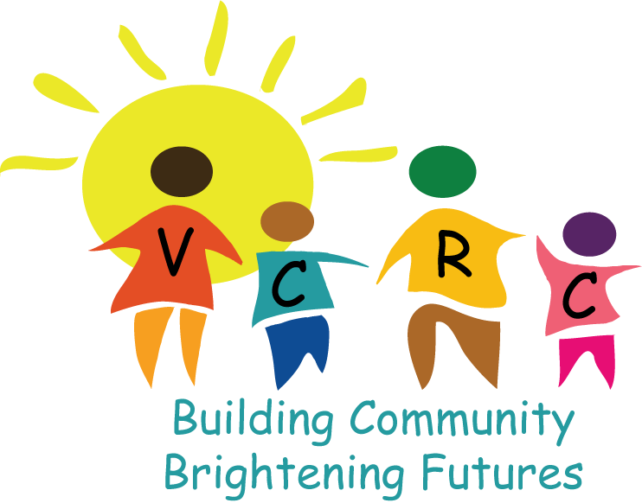
Program Director
Village Community Resource Center
Full-time, exempt employee

We're looking for a Program Director who is fluent in Spanish and has extensive experience in K-5 education to grow our Afterschool Academy and oversee our new Child Care Cooperative.

Background
Village Community Resource Center (VCRC) in Brentwood, California is a community-based non-profit organization (501 c3) that serves low and very low income families in Far East Contra Costa County. While the majority of our clients are Latino; VCRC does not discriminate because of age, race, gender, national origin, ethnicity, residential status, veteran states, sexual orientation or disability.

The mission of VCRC is to provide information, support, and coordination of resources to empower and improve the quality of life of disadvantaged children and their families in a culturally sensitive environment. We believe in being advocates for the families we serve while empowering them to advocate for themselves, toward the goal of being self-sufficient. VCRC offers a variety of supportive services and activities for children, youth, and families in a safe and nurturing environment. Services are prevention-focused, family-friendly, and available in English and Spanish. VCRC provides access to resources, which improve neighborhood and community conditions by implementing educational, social services, and health components.

Programs
The After School Academy provides educational assistance for children from Kindergarten through 5th grade. Currently 87 students are enrolled, receiving education support three days a week. In 2015, we plan to open a satellite site in Byron which will serve up to 40 students during the 2015-2016 academic year and up to 90 students by 2017. In addition to academic support, we provide key educational links between parents and K-8 school sites by meeting with administrators, teachers, and staff. We help families navigate the school system, understand policies and procedures, and advocate for students when necessary so that our students might have opportunities equal to their classmates.

We believe parental engagement in their child’s academic life is vital to student success. For this reason, we require parents of Kindergarten-5th grade students in our program to attend monthly parent meetings. Parent meetings cover educational topics and train parents how to best provide academic support for their children. Here are descriptions of our targeted programs in the After School Academy:

Read to Succeed – Literacy Program (Kinder-3rd Grade)
Our new Literacy Program provides intensive support for Kindergarten-3rd grade students through phonics, sound blending, and reading comprehension. The program teaches letters through sounds and movement, which are reinforced with games and activities. As students progress, the focus turns to fluency and reading comprehension taught through interactive, hands-on activities as well as computer tutorials which show students how to be proactive readers.

Homework Club (4th-5th Grade)
The goal of this program is to assist and guide students toward independent completion of homework while exposing them to the opportunity of pursuing higher education. Focus is placed on problem solving techniques, literacy and writing strategies, research assistance and math skills. Daily homework logs detailing level of homework completion, reasons for non-completion (if applicable), and remaining assignments needing to be completed at home ensure regular communication with parents.

In addition to the educational programs listed above, we also provide free translation and advocacy services as well as referrals to other local services agencies. Every Saturday, John Muir Mobile Health Clinic comes to our center to provide free medical services to those who are uninsured or underinsured.

Child Care Cooperative – Future Program

Realizing that quality child care often impedes adults from furthering their own education; VCRC plans to provide free child care beginning in 2016. Parents utilizing this service will be required to participate in weekly parent classes. New learning will be reinforced through completion of scheduled volunteer hours in the Child Care Cooperative. Under the supervision of a Child Care Director, the Cooperative will initially serve up to seventeen (2-5 year old) children daily.
Position: This position is full-time, exempt and will require occasional weekend/evening hours.
Qualifications
This is an extraordinary opportunity for an individual with team management experience to grow and further develop a proven program. Reporting to the Executive Director (ED) and Assistant ED, the Program Director will be responsible for the operational success of Village Community Resource Center ensuring seamless team management and development, program delivery, and quality control and evaluation. The successful candidate will work collaboratively with staff, volunteers, partners, and the community.

Specific requirements include:
- Bachelor's degree or equivalent experience
- Fluency in Spanish (written and verbal) is required
- Demonstrated experience problem solving, balancing priorities, and creative management of multiple tasks.
- Effectively empowers others to reach their goals and increase their levels of responsibility.
- Excellent people skills including verbal and written communication skills
  - Demonstrate Computer Literacy, Word, Excel, Microsoft office.
- Resourceful, results oriented team-player with a positive attitude, and a sense of humor.
- Personal qualities of integrity, credibility, maturity, confidence and commitment.

Responsibilities (not limited to)
Program
- Responsible for supervision & delivery of the K-5th grade After School Academy at two service sites
- Supervises and ensures quality delivery of Early Childhood programs and Parent classes.
- Manages communication with school sites working closely with school administrators and teachers to enhance sharing so that students might reach their individual goals.
- Plan & execute Afterschool Academy events (registration, parent meetings, fundraisers & graduation)
- Aid in database maintenance (including records and reports, budgets, & personnel records).
- Provide direct service and support to individuals or clients, such as handling a referral for advocacy issues, conducting a needs evaluation, or resolving complaints.
- Compile data regarding program outcomes

Staff/Volunteer
- Together with the management team: recruit, interview, train and oversee program staff (Case Manager, Early Childhood Director, After School Academy Program Coordinators and Assistants)
- Aid in the development, implementation and evaluation of an orientation/training program for staff & volunteers.
- Coordinates the activities and supervises the work of volunteers and program staff to ensure that programs are of appropriate quality and that resources are used effectively.
  - Provide ongoing professional development that builds the capacity of afterschool staff to support student achievement (includes coaching, modeling, observation/feedback, & trainings)
  - Provide ongoing technical assistance related to research based practices in literacy, teaching strategies, classroom management, and academic learning.
- Manages the volunteer program

Outreach
- Speak to community groups to explain and interpret agency purposes, programs, and policies.
- Works effectively to build relationships within a diverse community
- Collaborates with other service agencies to enhance service to the community

Candidates interested in this position should contact Kirsten Rigsby: kirsten@vcrcbrentwoodca.org

