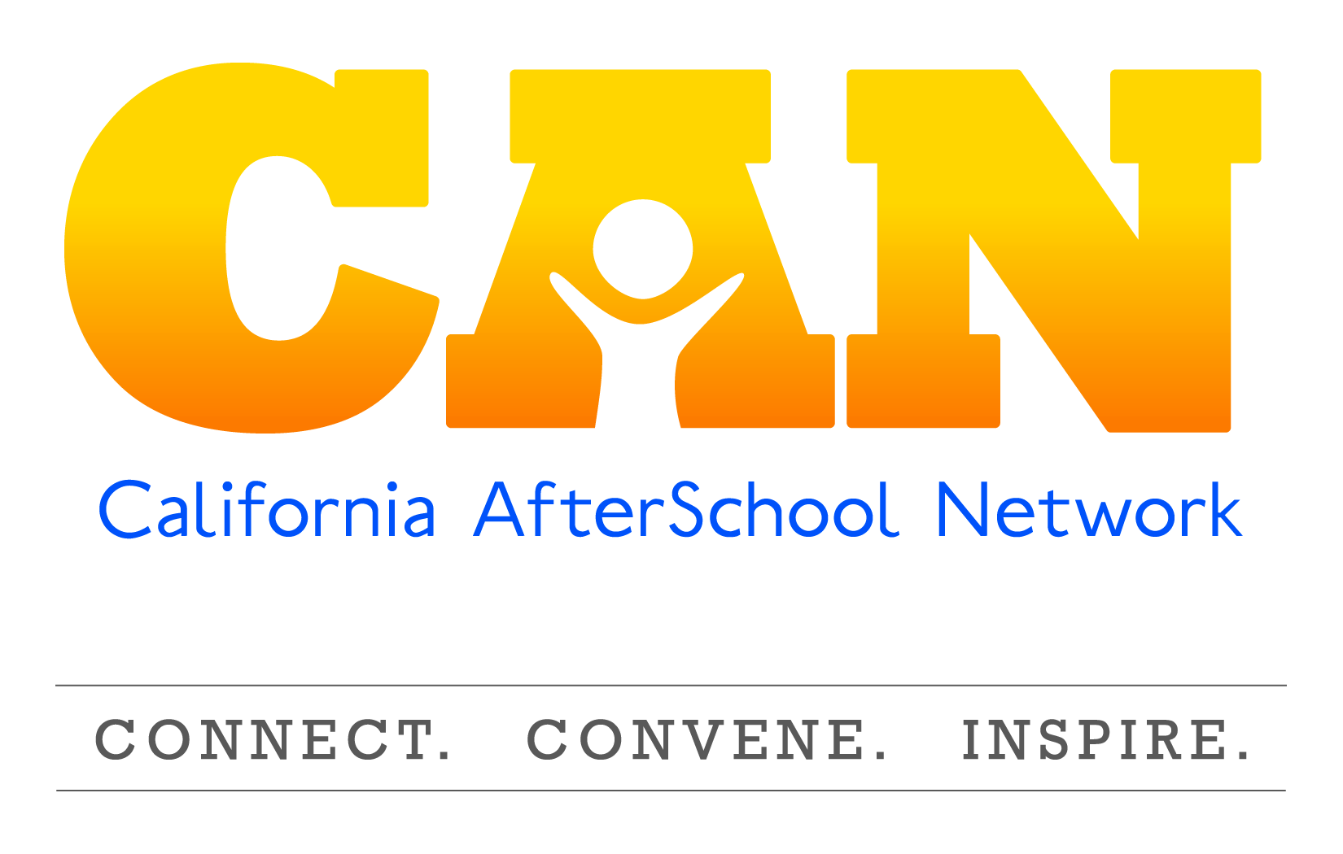

**STEM Committee Meeting**

**February 12, 2016**

**10:00a.m. – 11:00a.m.**

*Call:* 888-450-4821

*Enter code:* 273368(#)

*Click*: <http://foundationccc.adobeconnect.com/stem-committee-feb-meeting/>

**Agenda Items**

1. Welcome to the STEM Committee 2015!
2. Update on the California AfterSchool Network
3. **Summer Matters Science, Jessica Manta-Meyer , Public Profit**

Presenters:

* Jessica Manta-Meyer, Public Profit

1. Workgroup Formation and Work Plans
2. Announcements and available resources to support STEM learning in expanded learning programs.

***We look forward to another exciting year for the CAN STEM Committee***